HOLY TRINITY SUNDAY
May 30, 2021

Divine Service 1

Confession and Absolution

504 Father Most Holy
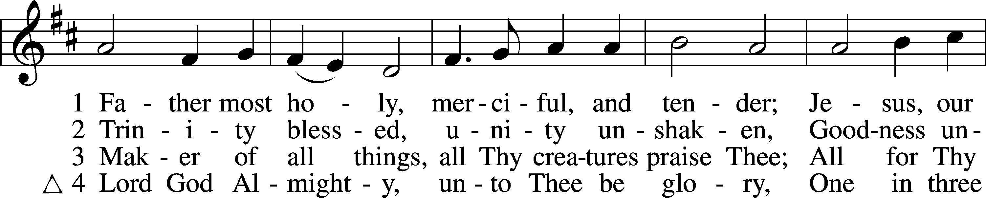
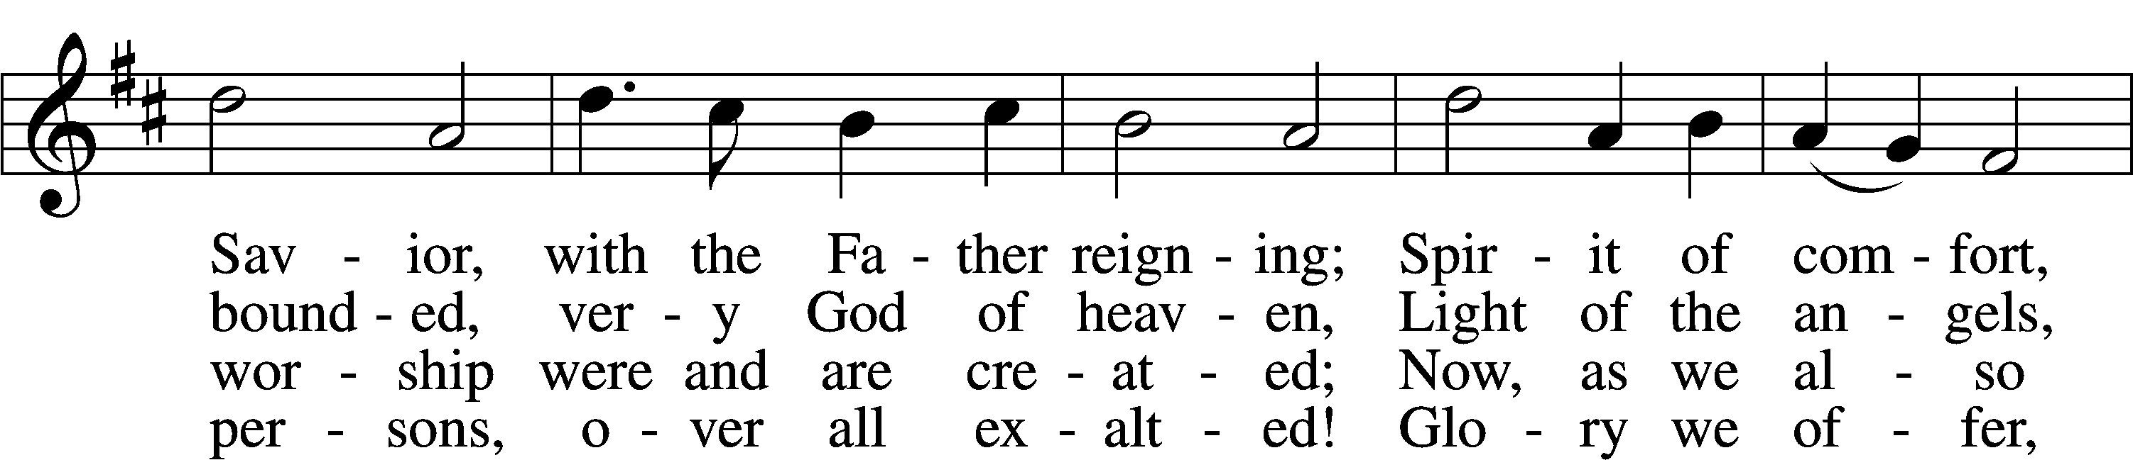
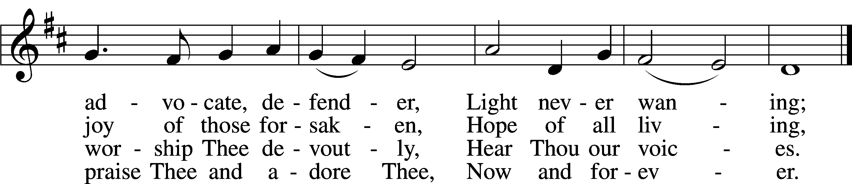
Tune and text: Public domain

P In the name of the Father and of the T Son and of the Holy Spirit.
C Amen.

P If we say we have no sin, we deceive ourselves, and the truth is not in us.
C But if we confess our sins, God, who is faithful and just, will forgive our sins and cleanse us from all unrighteousness.

P Let us then confess our sins to God our Father.
C Most merciful God, we confess that we are by nature sinful and unclean. We have sinned against You in thought, word, and deed, by what we have done and by what we have left undone. We have not loved You with our whole heart; we have not loved our neighbors as ourselves. We justly deserve Your present and eternal punishment. For the sake of Your Son, Jesus Christ, have mercy on us. Forgive us, renew us, and lead us, so that we may delight in Your will and walk in Your ways to the glory of Your holy name. Amen.

P Almighty God in His mercy has given His Son to die for you and for His sake forgives you all your sins. As a called and ordained servant of Christ, and by His authority, I therefore forgive you all your sins in the name of the Father and of the T Son and of the Holy Spirit.
C Amen.

Service of the Word

Introit Psalm 16:8–11; antiphon: Liturgical Text
Blessèd be the Holy Trinity and the undivided Unity.
Let us give glory to him because he has shown his mercy to us.
I have set the Lord always before me;
because he is at my right hand, I shall not be shaken.
Therefore my heart is glad, and my whole being rejoices;
my flesh also dwells secure.
For you will not abandon my soul to Sheol,
or let your holy one see corruption.
You make known to me the path of life;
in your presence there is fullness of joy; at your right hand are pleasures forevermore.
Glory be to the Father and to the Son
and to the Holy Spirit;
as it was in the beginning,
is now, and will be forever. Amen.
Blessèd be the Holy Trinity and the undivided Unity.
Let us give glory to him because he has shown his mercy to us.

Kyrie LSB 152
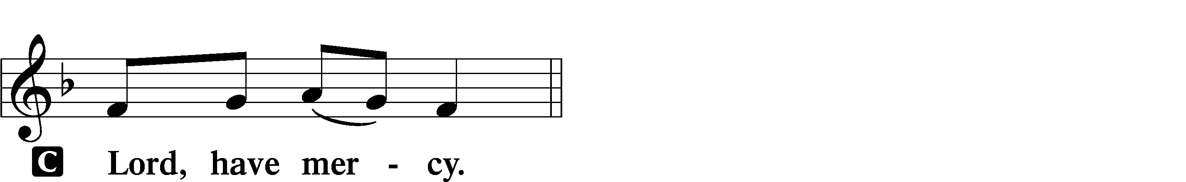

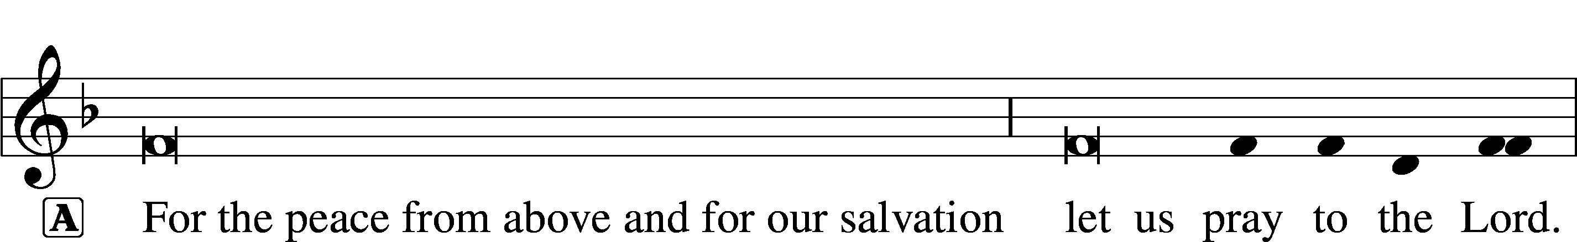
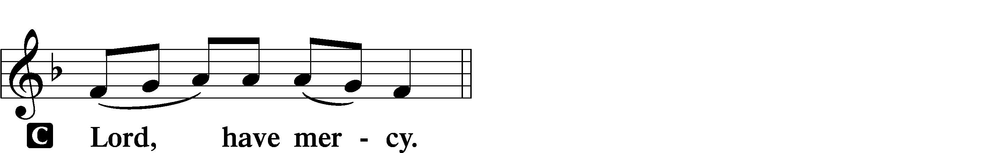

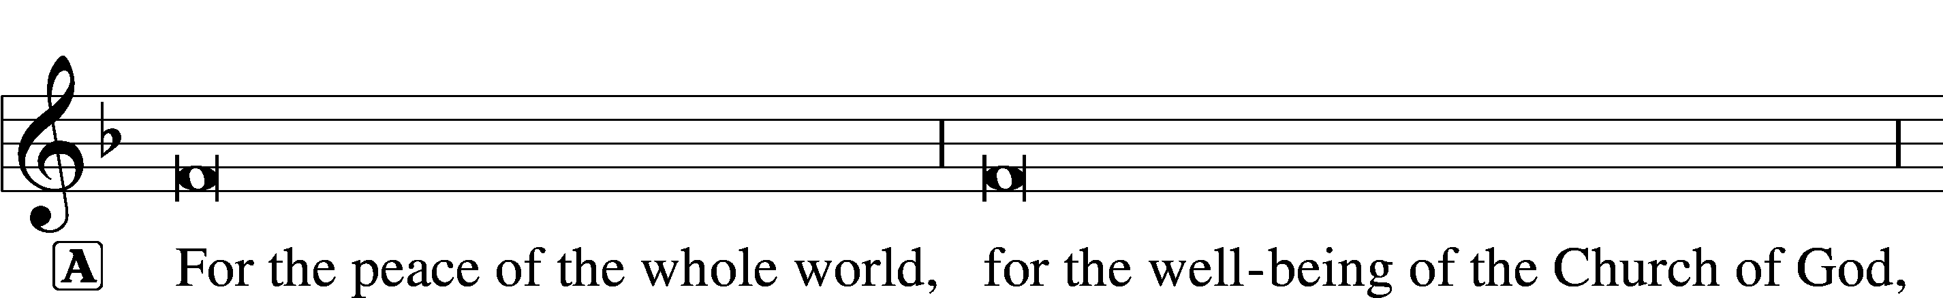
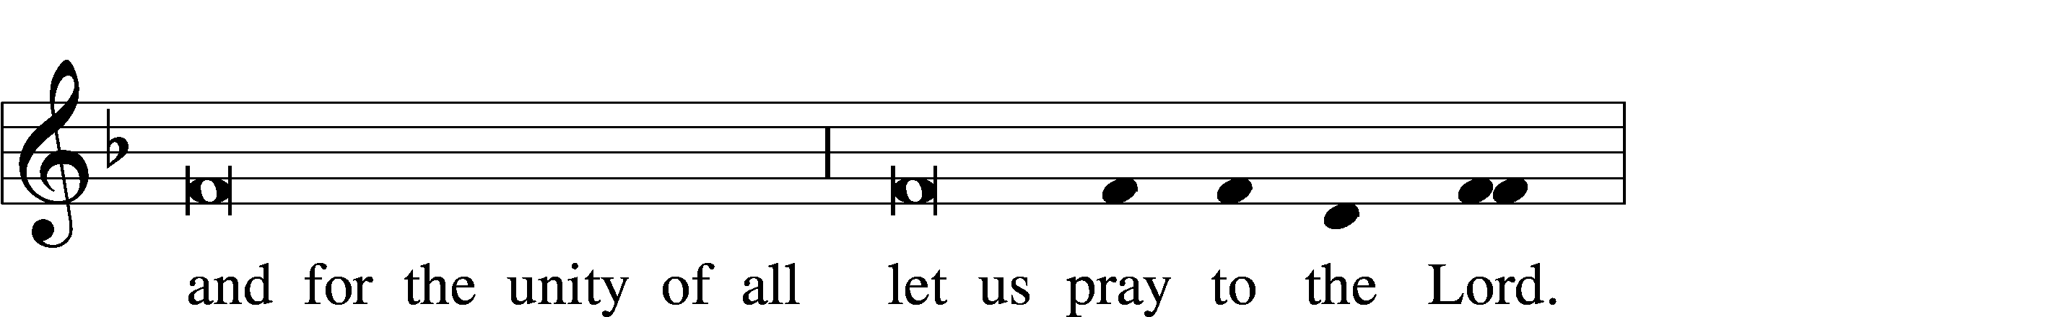
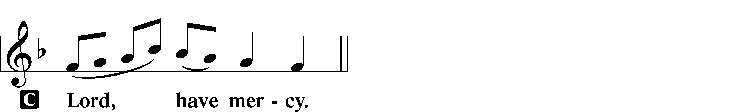

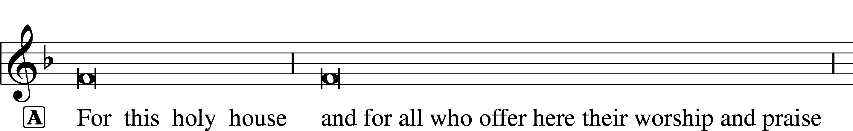
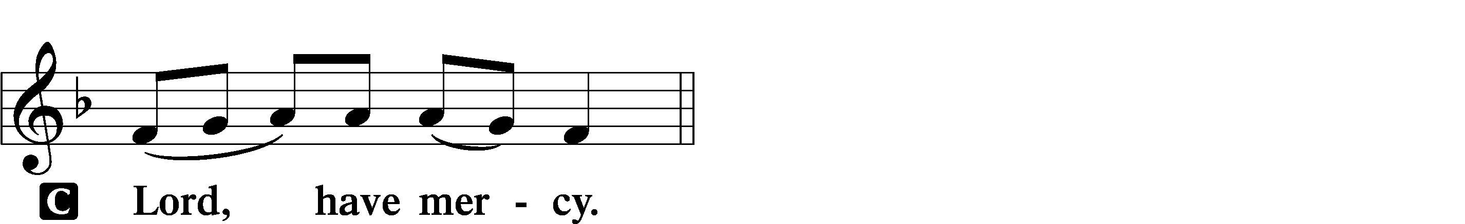

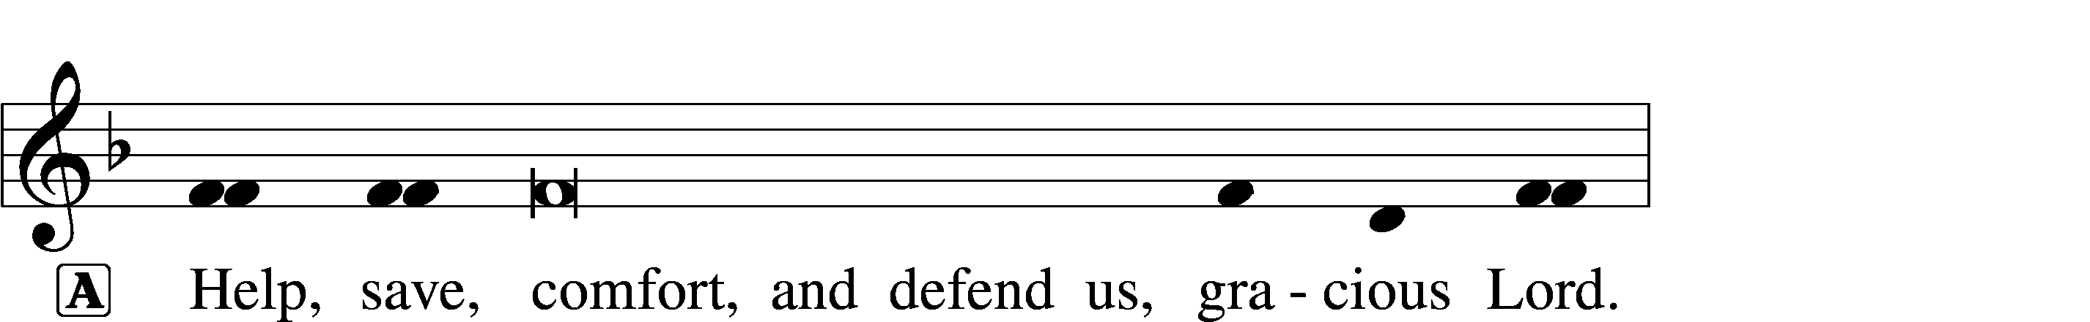

This Is the Feast LSB 155
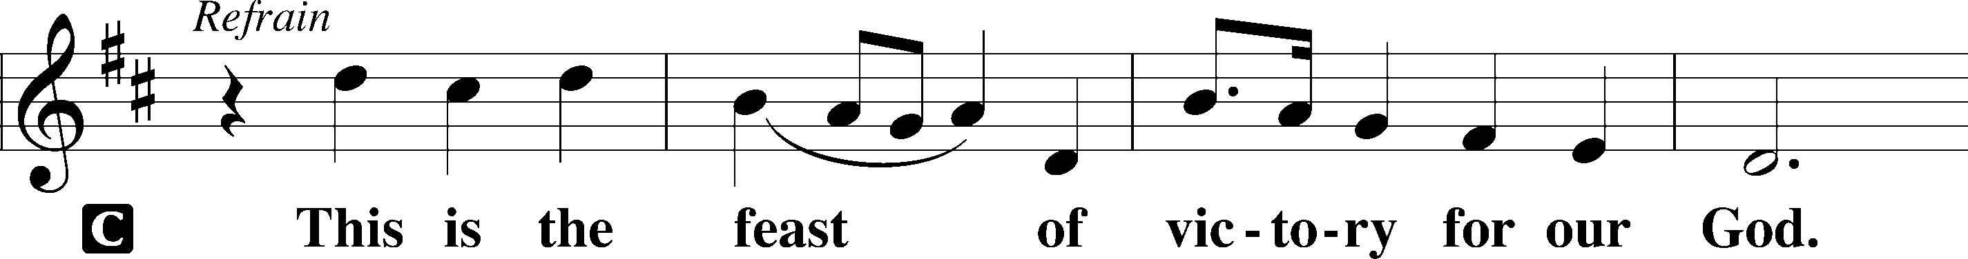
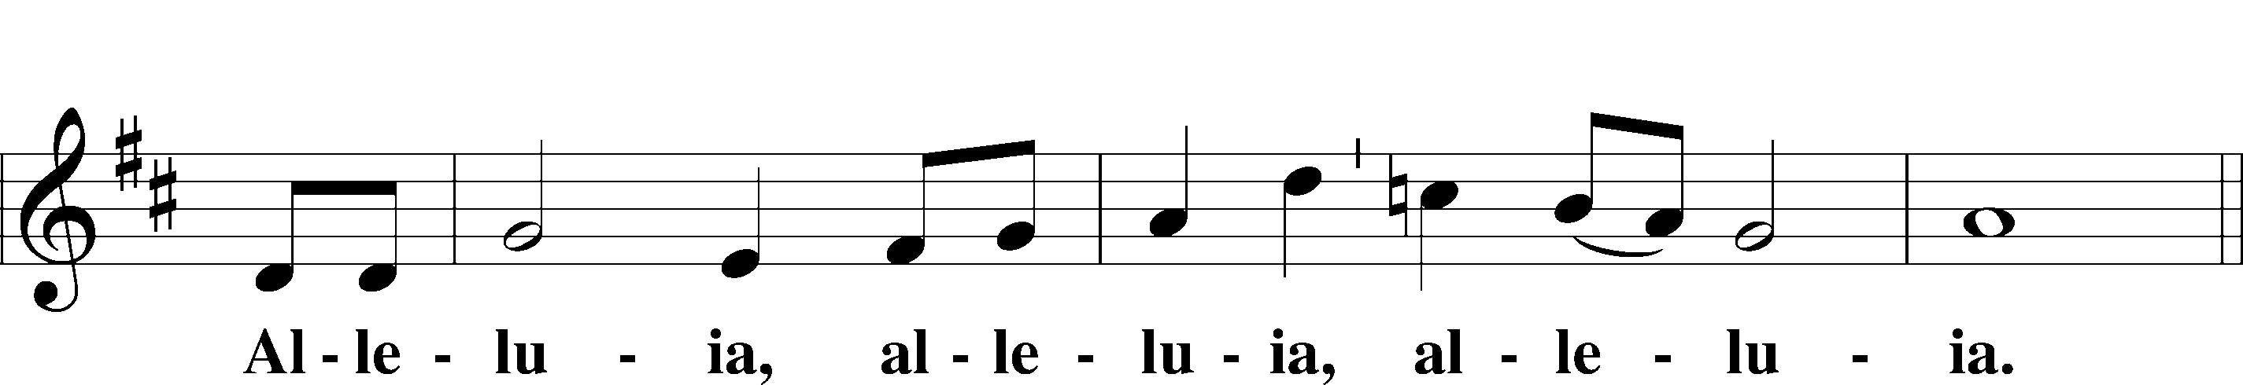
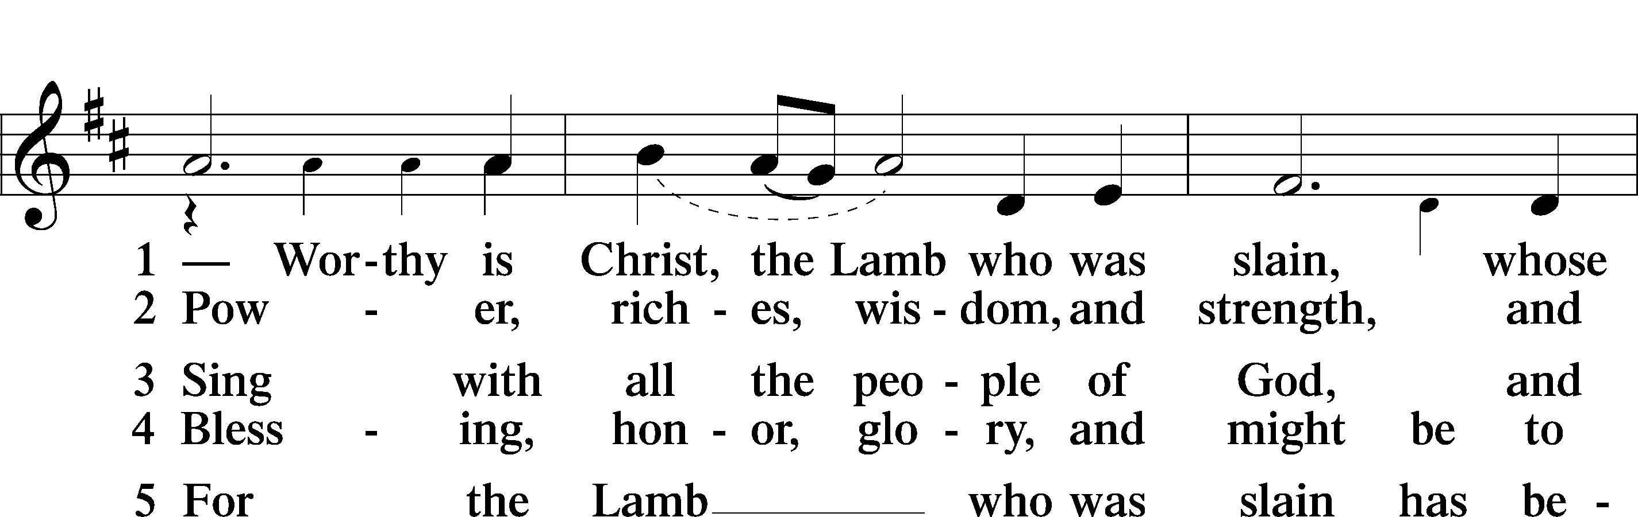
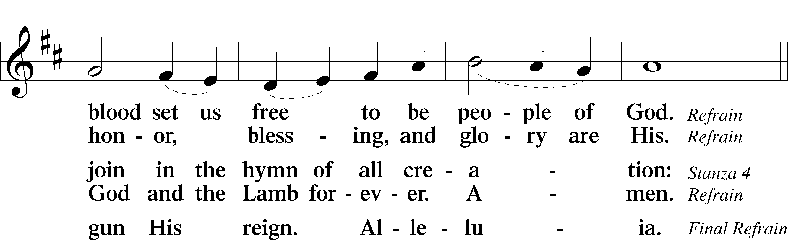
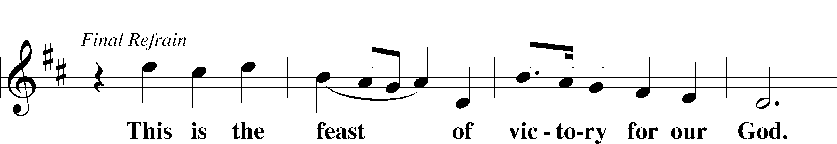
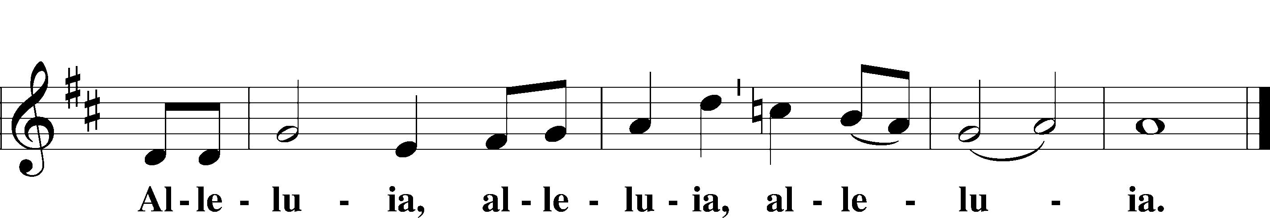

Salutation and Collect of the Day
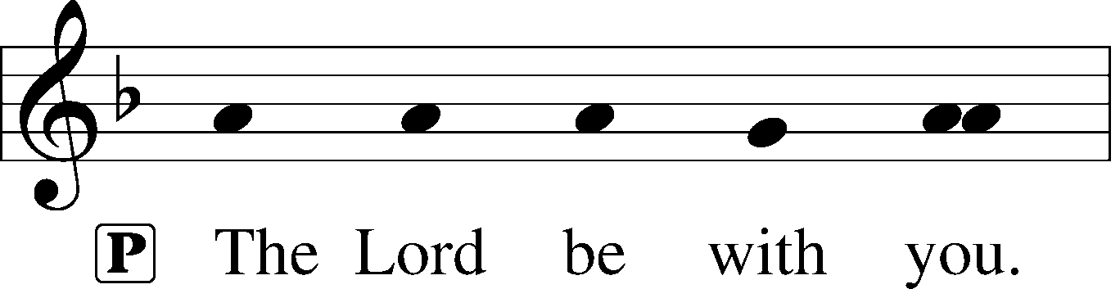
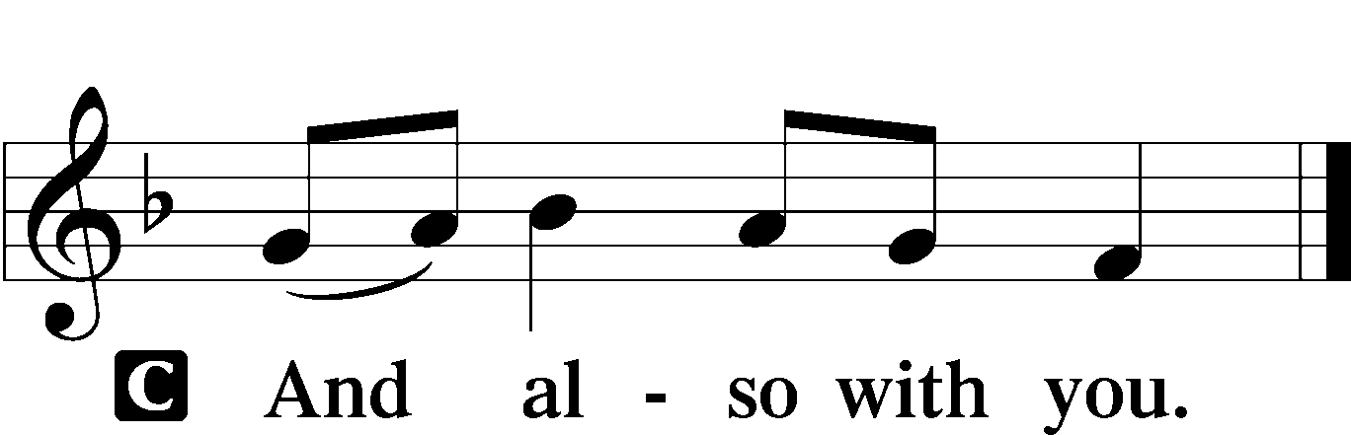

P Let us pray.
Almighty and everlasting God, You have given us grace to acknowledge the glory of the eternal Trinity by the confession of a true faith and to worship the Unity in the power of the Divine Majesty. Keep us steadfast in this faith and defend us from all adversities; for You, O Father, Son, and Holy Spirit, live and reign, one God, now and forever.

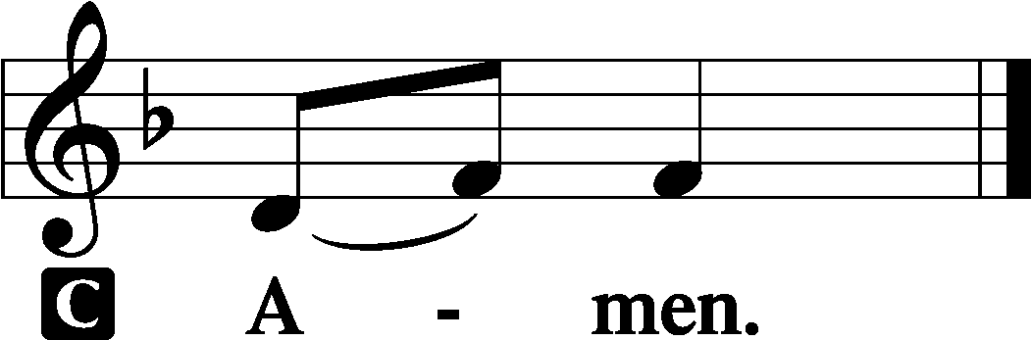

Old Testament Reading Isaiah 6:1–8
Isaiah’s Vision of the Lord
In the year that King Uzziah died I saw the Lord sitting upon a throne, high and lifted up; and the train of his robe filled the temple. Above him stood the seraphim. Each had six wings: with two he covered his face, and with two he covered his feet, and with two he flew. And one called to another and said:
“Holy, holy, holy is the Lord of hosts;
the whole earth is full of his glory!”
And the foundations of the thresholds shook at the voice of him who called, and the house was filled with smoke. And I said: “Woe is me! For I am lost; for I am a man of unclean lips, and I dwell in the midst of a people of unclean lips; for my eyes have seen the King, the Lord of hosts!”
Then one of the seraphim flew to me, having in his hand a burning coal that he had taken with tongs from the altar. And he touched my mouth and said: “Behold, this has touched your lips; your guilt is taken away, and your sin atoned for.”
Isaiah’s Commission from the Lord
And I heard the voice of the Lord saying, “Whom shall I send, and who will go for us?” Then I said, “Here am I! Send me.”

A This is the Word of the Lord.
C Thanks be to God.

Second Reading Acts 2:14a, 22–36
Peter’s Sermon at Pentecost
Peter, standing with the eleven, lifted up his voice and addressed them, . . .
“Men of Israel, hear these words: Jesus of Nazareth, a man attested to you by God with mighty works and wonders and signs that God did through him in your midst, as you yourselves know— this Jesus, delivered up according to the definite plan and foreknowledge of God, you crucified and killed by the hands of lawless men. God raised him up, loosing the pangs of death, because it was not possible for him to be held by it. For David says concerning him,
“‘I saw the Lord always before me,
for he is at my right hand that I may not be shaken;
therefore my heart was glad, and my tongue rejoiced;
my flesh also will dwell in hope.
For you will not abandon my soul to Hades,
or let your Holy One see corruption.
You have made known to me the paths of life;
you will make me full of gladness with your presence.’
“Brothers, I may say to you with confidence about the patriarch David that he both died and was buried, and his tomb is with us to this day. Being therefore a prophet, and knowing that God had sworn with an oath to him that he would set one of his descendants on his throne, he foresaw and spoke about the resurrection of the Christ, that he was not abandoned to Hades, nor did his flesh see corruption. This Jesus God raised up, and of that we all are witnesses. Being therefore exalted at the right hand of God, and having received from the Father the promise of the Holy Spirit, he has poured out this that you yourselves are seeing and hearing. For David did not ascend into the heavens, but he himself says,
“‘The Lord said to my Lord,
Sit at my right hand,
until I make your enemies your footstool.’
Let all the house of Israel therefore know for certain that God has made him both Lord and Christ, this Jesus whom you crucified.”

A This is the Word of the Lord.
C Thanks be to God.

Alleluia and Verse LSB 156
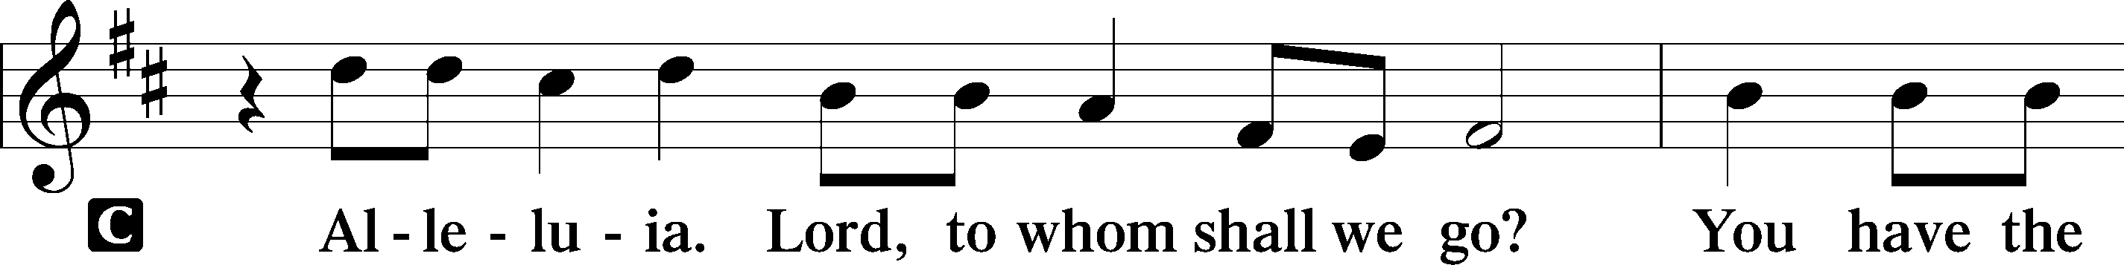
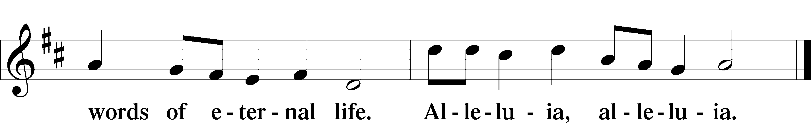

Holy Gospel John 3:1–17
P The Holy Gospel according to St. John, the third chapter.

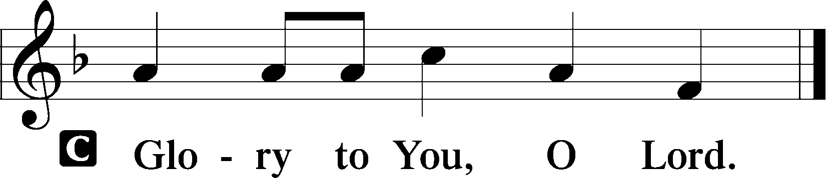

You Must Be Born Again
Now there was a man of the Pharisees named Nicodemus, a ruler of the Jews. This man came to Jesus by night and said to him, “Rabbi, we know that you are a teacher come from God, for no one can do these signs that you do unless God is with him.” Jesus answered him, “Truly, truly, I say to you, unless one is born again he cannot see the kingdom of God.” Nicodemus said to him, “How can a man be born when he is old? Can he enter a second time into his mother’s womb and be born?” Jesus answered, “Truly, truly, I say to you, unless one is born of water and the Spirit, he cannot enter the kingdom of God. That which is born of the flesh is flesh, and that which is born of the Spirit is spirit. Do not marvel that I said to you, ‘You must be born again.’ The wind blows where it wishes, and you hear its sound, but you do not know where it comes from or where it goes. So it is with everyone who is born of the Spirit.”
Nicodemus said to him, “How can these things be?” Jesus answered him, “Are you the teacher of Israel and yet you do not understand these things? Truly, truly, I say to you, we speak of what we know, and bear witness to what we have seen, but you do not receive our testimony. If I have told you earthly things and you do not believe, how can you believe if I tell you heavenly things? No one has ascended into heaven except he who descended from heaven, the Son of Man. And as Moses lifted up the serpent in the wilderness, so must the Son of Man be lifted up, that whoever believes in him may have eternal life.
For God So Loved the World
“For God so loved the world, that he gave his only Son, that whoever believes in him should not perish but have eternal life. For God did not send his Son into the world to condemn the world, but in order that the world might be saved through him.”

P This is the Gospel of the Lord.

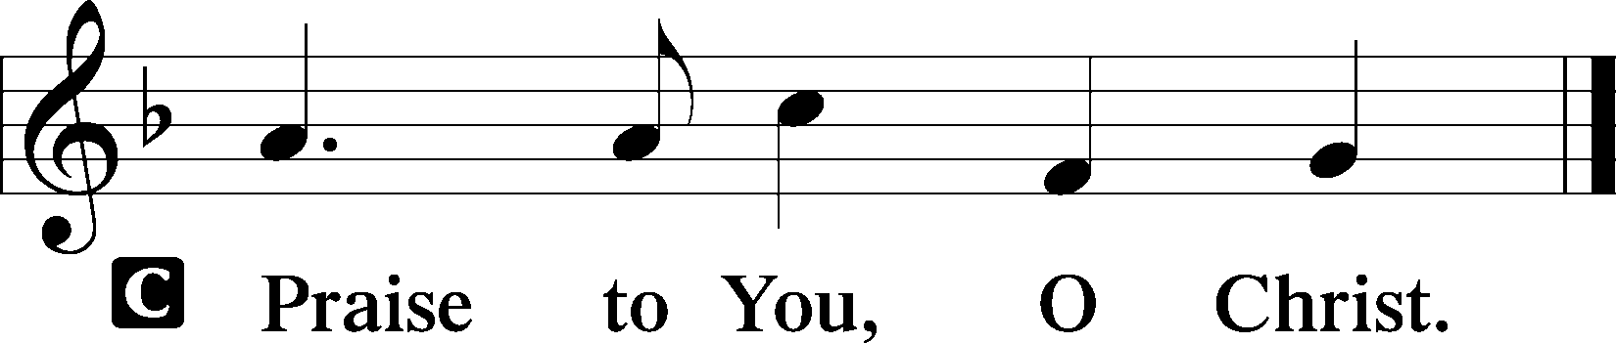

Athanasian Creed
L Whoever desires to be saved must, above all, hold the catholic faith.
C Whoever does not keep it whole and undefiled will without doubt perish eternally.
L And the catholic faith is this,
C that we worship one God in Trinity and Trinity in Unity, neither confusing the persons nor dividing the substance.
L For the Father is one person, the Son is another, and the Holy Spirit is another.
C But the Godhead of the Father and of the Son and of the Holy Spirit is one: the glory equal, the majesty coeternal.
L Such as the Father is, such is the Son, and such is the Holy Spirit:
C the Father uncreated, the Son uncreated, the Holy Spirit uncreated;
L the Father infinite, the Son infinite, the Holy Spirit infinite;
C the Father eternal, the Son eternal, the Holy Spirit eternal.
L And yet there are not three Eternals, but one Eternal,
C just as there are not three Uncreated or three Infinites, but one Uncreated and one Infinite.
L In the same way, the Father is almighty, the Son almighty, the Holy Spirit almighty;
C and yet there are not three Almighties, but one Almighty.
L So the Father is God, the Son is God, the Holy Spirit is God;
C and yet there are not three Gods, but one God.
L So the Father is Lord, the Son is Lord, the Holy Spirit is Lord;
C and yet there are not three Lords, but one Lord.
L Just as we are compelled by the Christian truth to acknowledge each distinct person as God and Lord, so also are we prohibited by the catholic religion to say that there are three Gods or Lords.
C The Father is not made nor created nor begotten by anyone.
L The Son is neither made nor created, but begotten of the Father alone.
C The Holy Spirit is of the Father and of the Son, neither made nor created nor begotten, but proceeding.
L Thus, there is one Father, not three Fathers; one Son, not three Sons; one Holy Spirit, not three Holy Spirits.
C And in this Trinity none is before or after another; none is greater or less than another;
L but the whole three persons are coeternal with each other and coequal, so that in all things, as has been stated above, the Trinity in Unity and Unity in Trinity is to be worshiped.
C Therefore, whoever desires to be saved must think thus about the Trinity.
L But it is also necessary for everlasting salvation that one faithfully believe the incarnation of our Lord Jesus Christ.
C Therefore, it is the right faith that we believe and confess that our Lord Jesus Christ, the Son of God, is at the same time both God and man.
L He is God, begotten from the substance of the Father before all ages; and He is man, born from the substance of His mother in this age:
C perfect God and perfect man, composed of a rational soul and human flesh;
L equal to the Father with respect to His divinity, less than the Father with respect to His humanity.
C Although He is God and man, He is not two, but one Christ:
L one, however, not by the conversion of the divinity into flesh, but by the assumption of the humanity into God;
C one altogether, not by confusion of substance, but by unity of person.
L For as the rational soul and flesh is one man, so God and man is one Christ,
C who suffered for our salvation, descended into hell, rose again the third day from the dead,
L ascended into heaven, and is seated at the right hand of the Father, God Almighty, from whence He will come to judge the living and the dead.
C At His coming all people will rise again with their bodies and give an account concerning their own deeds.
L And those who have done good will enter into eternal life, and those who have done evil into eternal fire.
C This is the catholic faith; whoever does not believe it faithfully and firmly cannot be saved.

506 Glory Be to God the Father
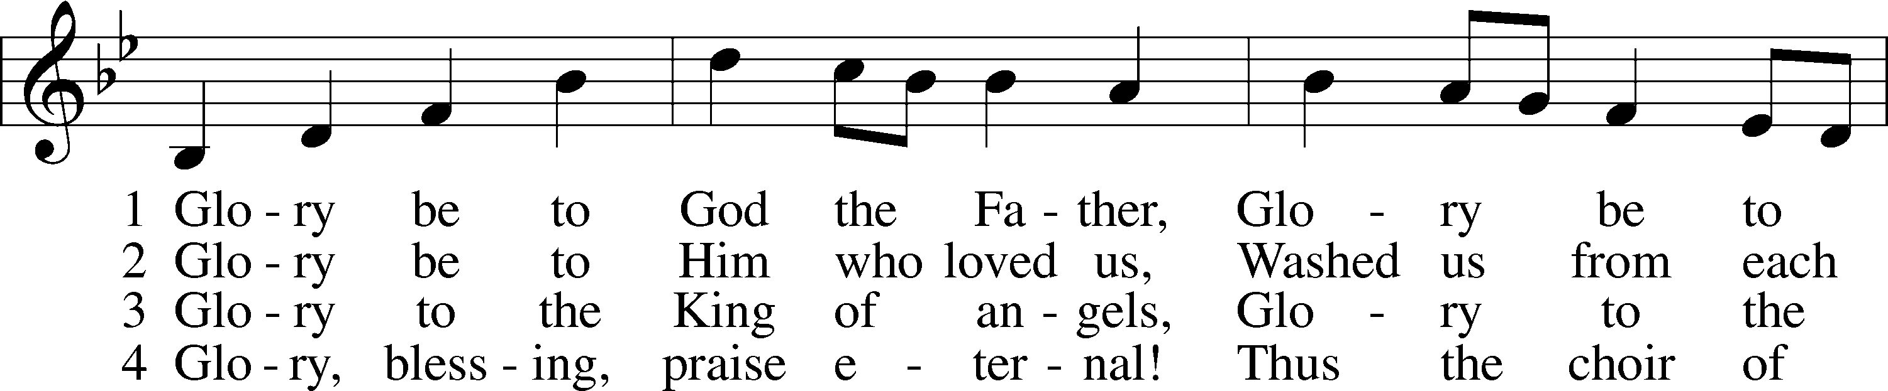
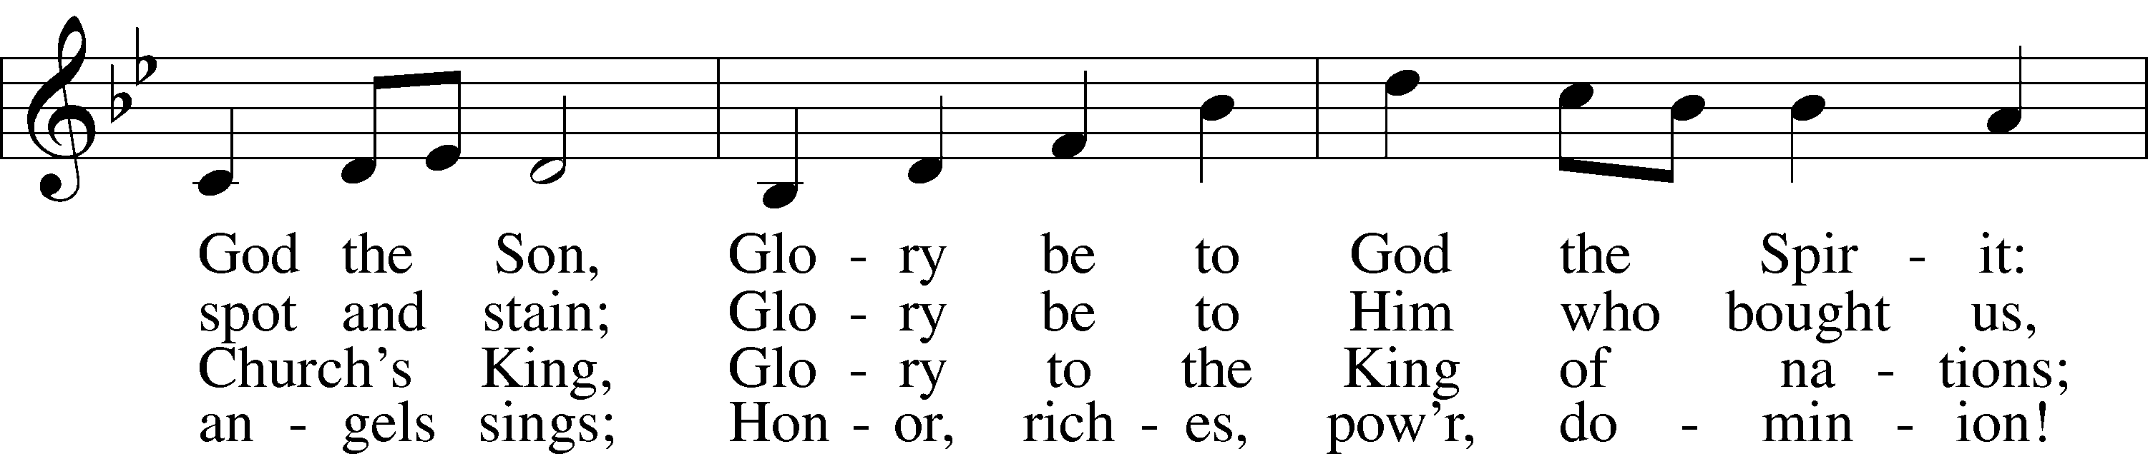
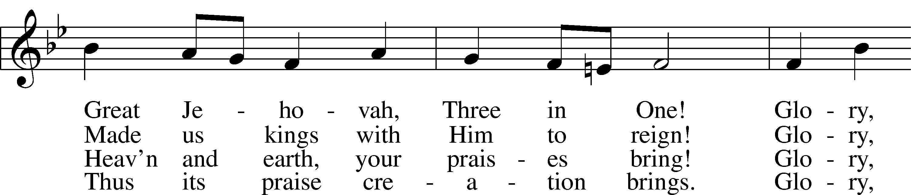
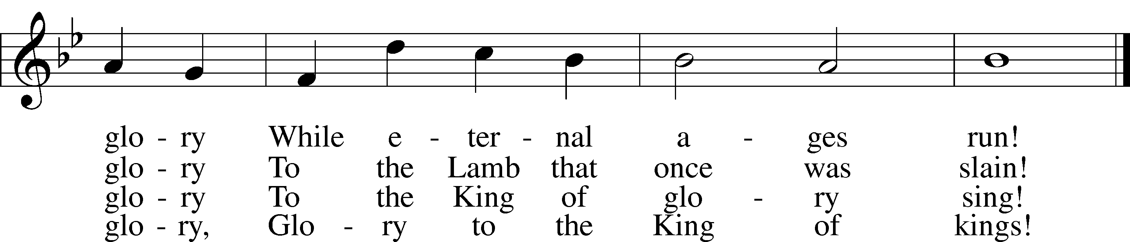
Tune and text: Public domain

Sermon

Offering

Offertory LSB 159
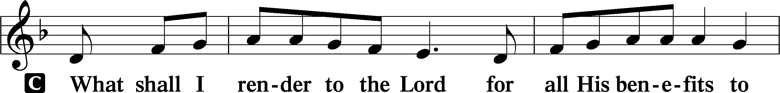
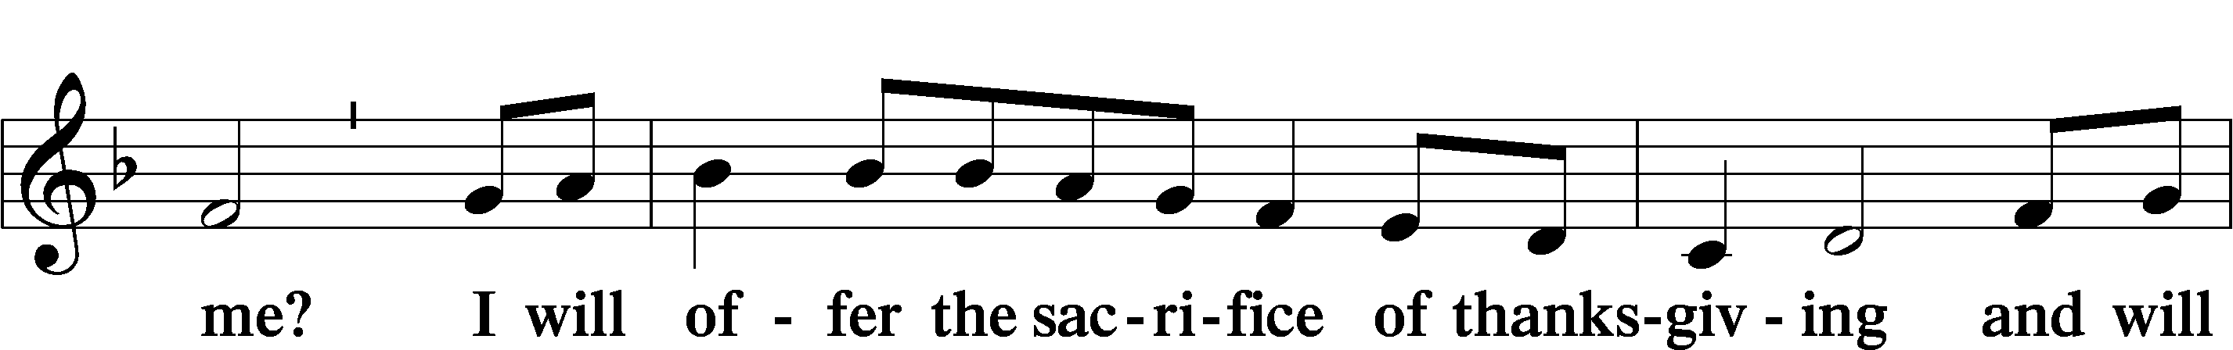
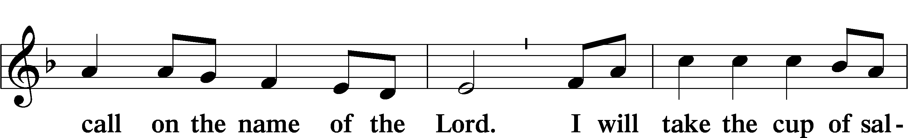
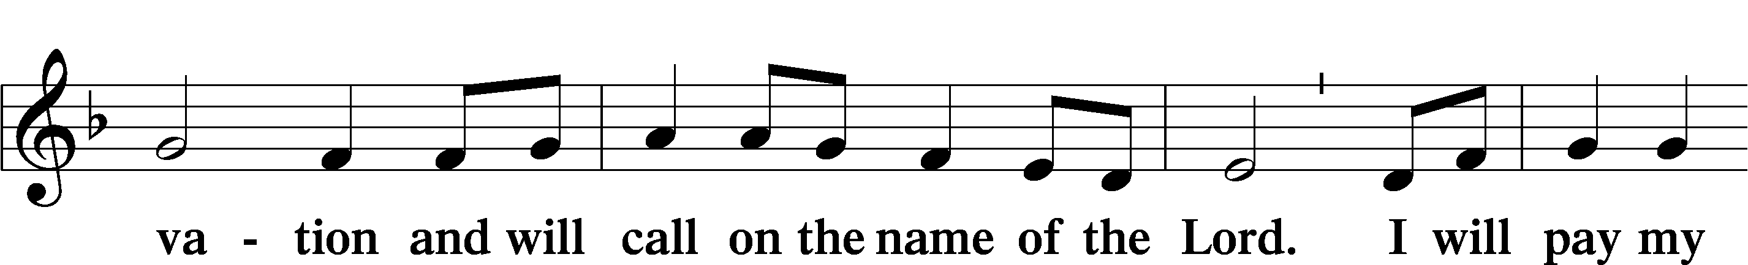
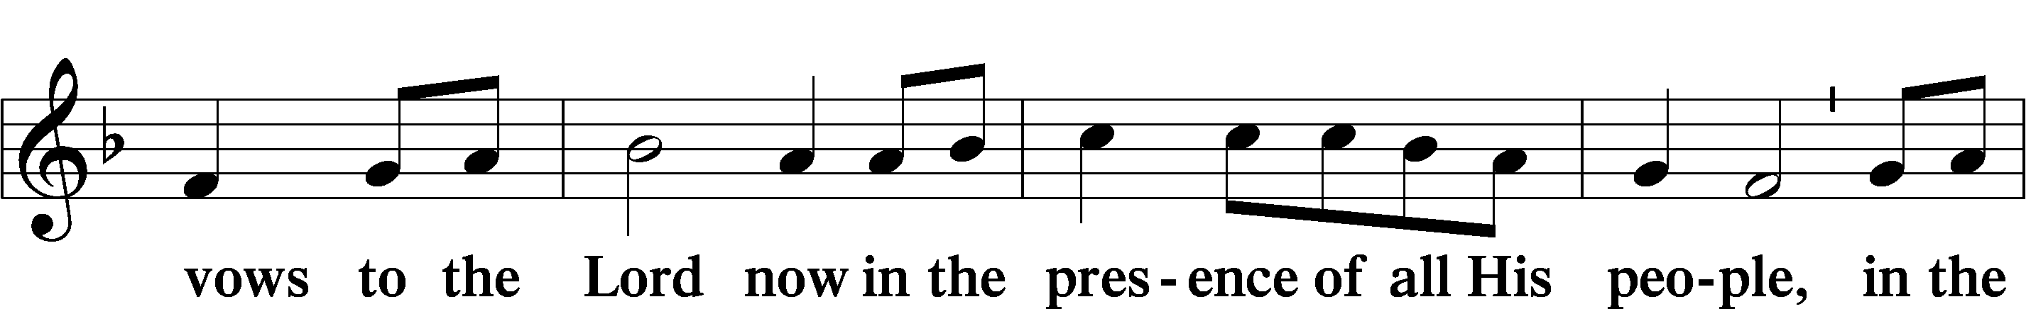
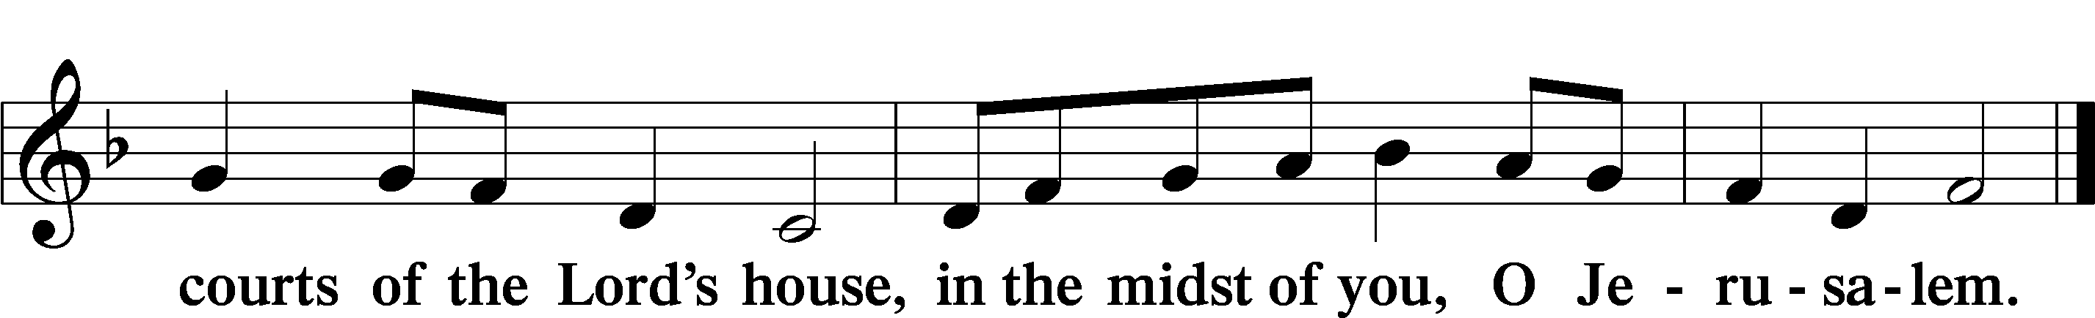

Prayer of the Church
P Let us pray for the whole Church of God in Christ Jesus and for all people according to their needs.

Lord of hosts, Your ways are inscrutable and Your judgments unsearchable. Through Your Word, give us an ever-growing understanding of the depths of Your riches, wisdom and knowledge, that we may glorify You forever. Lord, in Your mercy,
C hear our prayer.

P Lord of hosts, You gave Your only Son that whoever believes in Him should not perish but have eternal life. Bless the work of missionaries as they carry this Gospel to the ends of the earth, that many may hear of Your love in Your Son and be saved through Him. Lord, in Your mercy,
C hear our prayer.

P Lord of hosts, have mercy on those who would deny the new birth of water and the Spirit to infants and children. Open their eyes and hearts to the fullness of Your grace, that they would no longer hinder these little ones from being born again and seeing Your kingdom. Lord, in Your mercy,
C hear our prayer.

P Lord of hosts, we give thanks for those who have served our nation through military service, and we remember with gratitude those who gave their lives for us and for the cause of freedom. Help us to honor their sacrifice by using our liberty responsibly. Keep safe all who travel, bless our nation, and help us to protect and increase the privileges we have for those who follow us, looking always to You, from whom these privileges come. Lord, in Your mercy,
C hear our prayer.

P Lord of hosts, uphold _____________ and all who suffer in our midst by Your truth, that since You are at their right hand, they cannot be shaken. Gladden their hearts, cause their tongues to rejoice and make their flesh dwell in hope. Lord, in Your mercy,
C hear our prayer.

P Lord of hosts, take away our guilt and atone for our sin by touching our unclean lips with Christ’s cleansing body and blood, that we may not be lost but abide in Your holy presence forever. Lord in Your mercy,
C hear our prayer.

P All these things and whatever else You know that we need, grant us, Father, for the sake of Him who died and rose again and now lives and reigns with You and the Holy Spirit, one God forever.
C Amen.

Service of the Sacrament

Preface LSB 160
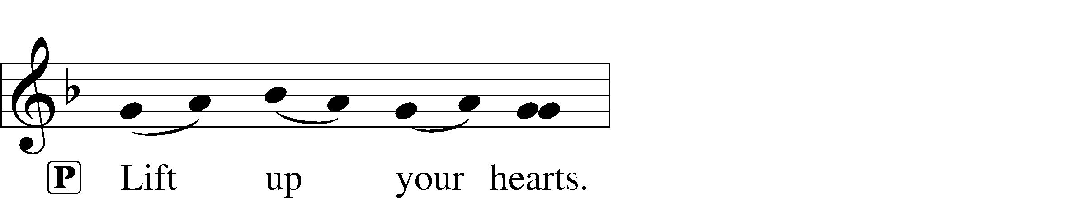
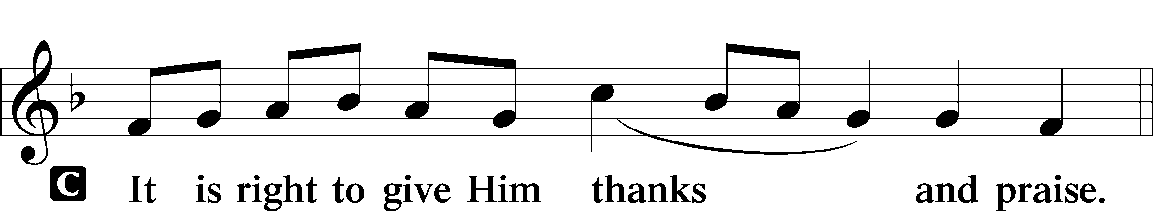

P It is truly good, right, and salutary that we should at all times and in all places give thanks to You, holy Lord, almighty Father, everlasting God, who with Your only-begotten Son and the Holy Spirit are one God, one Lord. In the confession of the only true God, we worship the Trinity in person and the Unity in substance, of majesty coequal. Therefore with angels and archangels and with all the company of heaven we laud and magnify Your glorious name, evermore praising You and saying:

Sanctus LSB 161
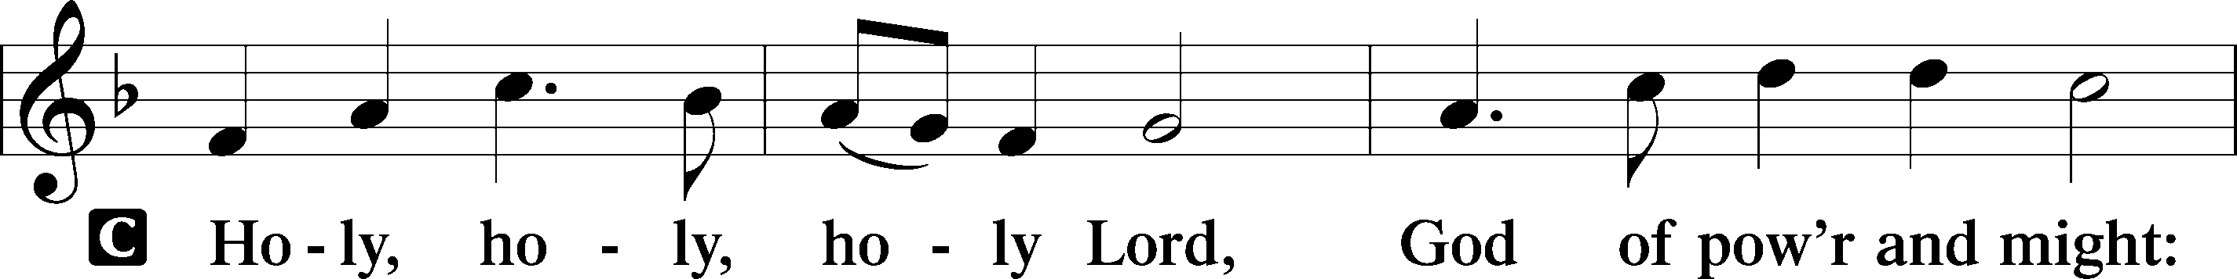
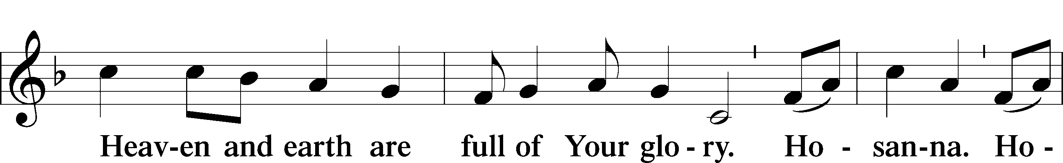
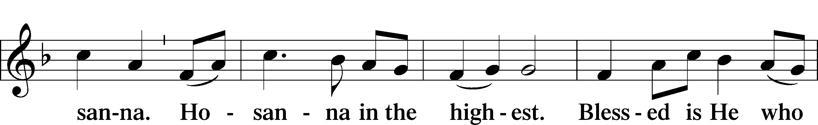
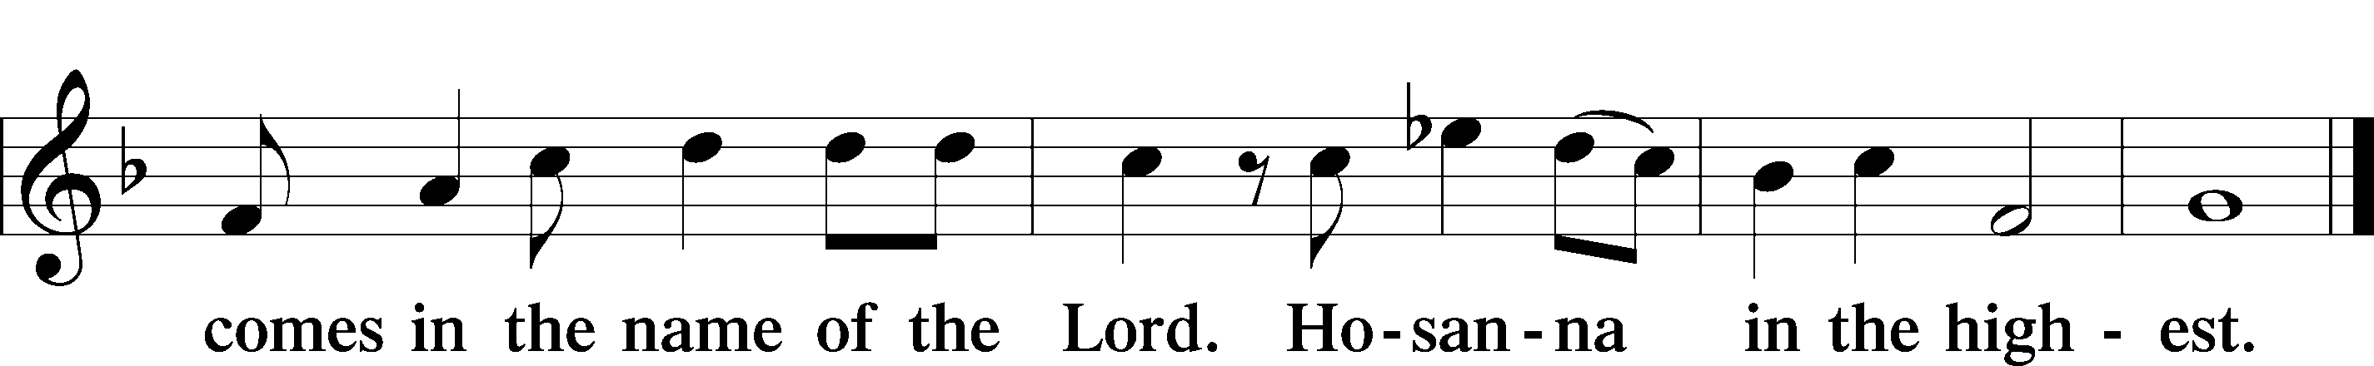

Prayer of Thanksgiving LSB 161
P Blessed are You, Lord of heaven and earth, for You have had mercy on those whom You created and sent Your only-begotten Son into our flesh to bear our sin and be our Savior. With repentant joy we receive the salvation accomplished for us by the all-availing sacrifice of His body and His blood on the cross.

Gathered in the name and the remembrance of Jesus, we beg You, O Lord, to forgive, renew, and strengthen us with Your Word and Spirit. Grant us faithfully to eat His body and drink His blood as He bids us do in His own testament. Gather us together, we pray, from the ends of the earth to celebrate with all the faithful the marriage feast of the Lamb in His kingdom, which has no end. Graciously receive our prayers; deliver and preserve us. To You alone, O Father, be all glory, honor, and worship, with the Son and the Holy Spirit, one God, now and forever.
C Amen.

Lord’s Prayer
C Our Father who art in heaven,
hallowed be Thy name,
Thy kingdom come,
Thy will be done on earth
as it is in heaven;
give us this day our daily bread;
and forgive us our trespasses
as we forgive those
who trespass against us;
and lead us not into temptation,
but deliver us from evil.
For Thine is the kingdom
and the power and the glory
forever and ever. Amen.

The Words of Our Lord
P Our Lord Jesus Christ, on the night when He was betrayed, took bread, and when He had given thanks, He broke it and gave it to the disciples and said: “Take, eat; this is My T body, which is given for you. This do in remembrance of Me.”

In the same way also He took the cup after supper, and when He had given thanks, He gave it to them, saying: “Drink of it, all of you; this cup is the new testament in My T blood, which is shed for you for the forgiveness of sins. This do, as often as you drink it, in remembrance of Me.”

P As often as we eat this bread and drink this cup, we proclaim the Lord’s death until He comes.
C Amen. Come, Lord Jesus.

P O Lord Jesus Christ, only Son of the Father, in giving us Your body and blood to eat and to drink, You lead us to remember and confess Your holy cross and passion, Your blessed death, Your rest in the tomb, Your resurrection from the dead, Your ascension into heaven, and Your coming for the final judgment. So remember us in Your kingdom and teach us to pray:

Pax Domini LSB 163
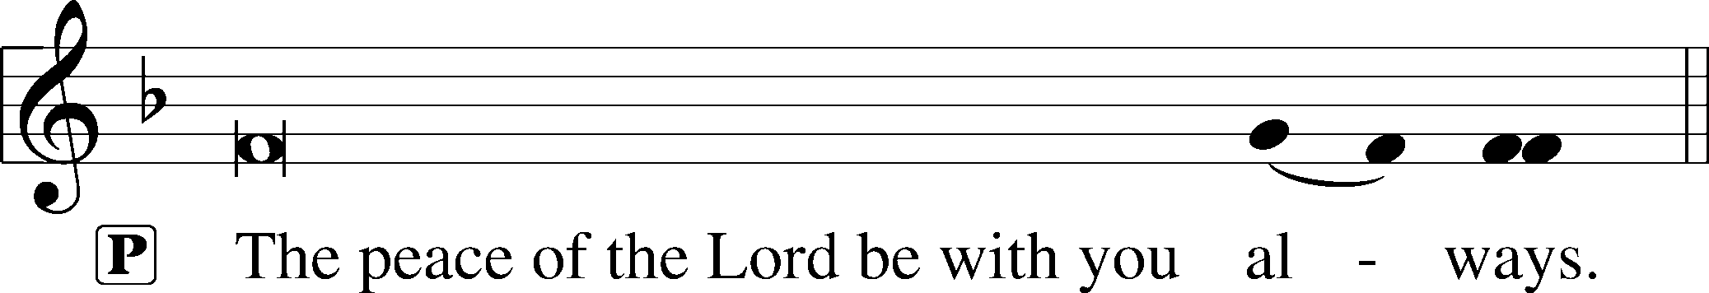

Agnus Dei LSB 163
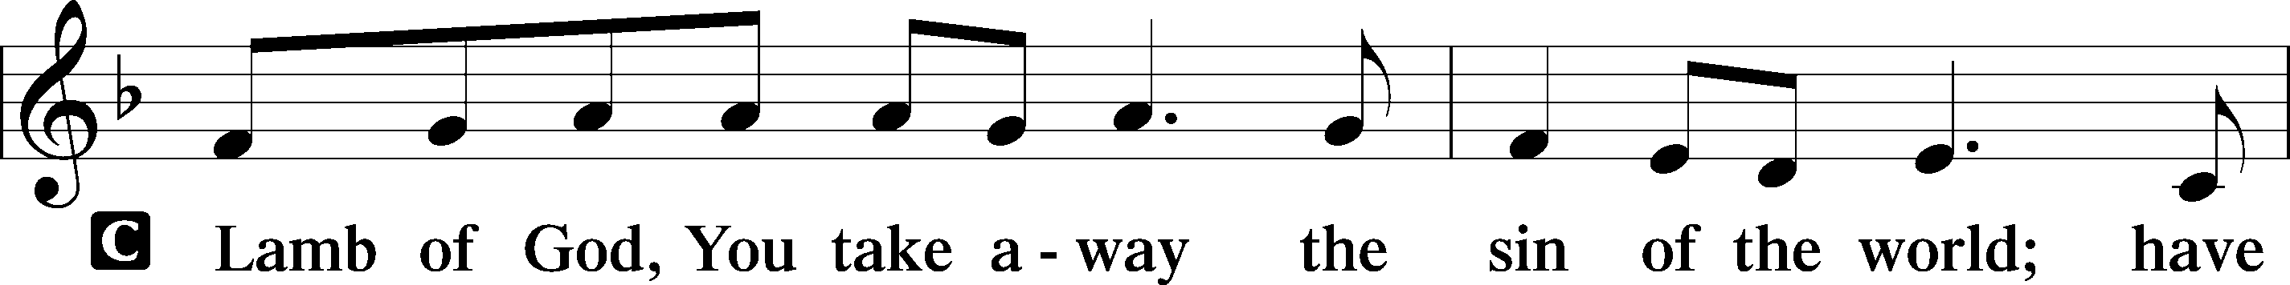
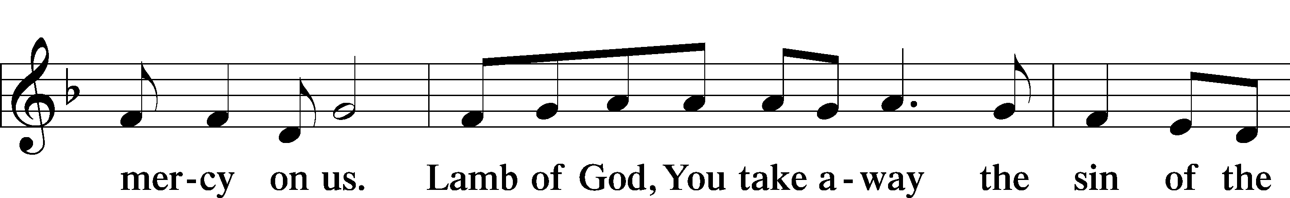
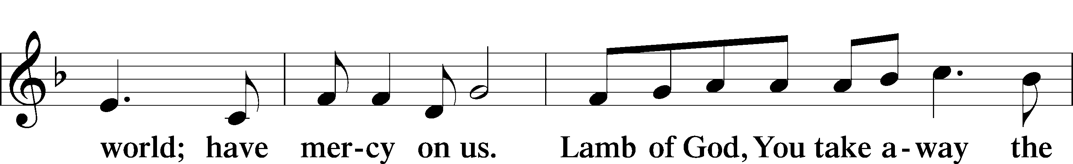
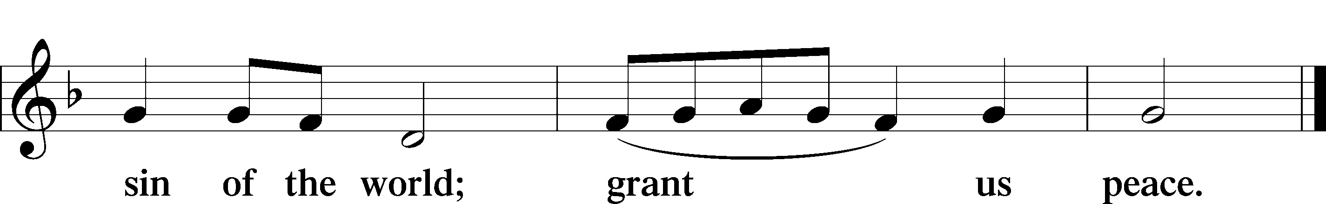

Distribution

628 Your Table I Approach
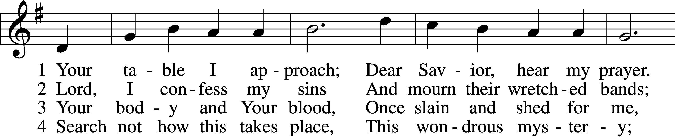
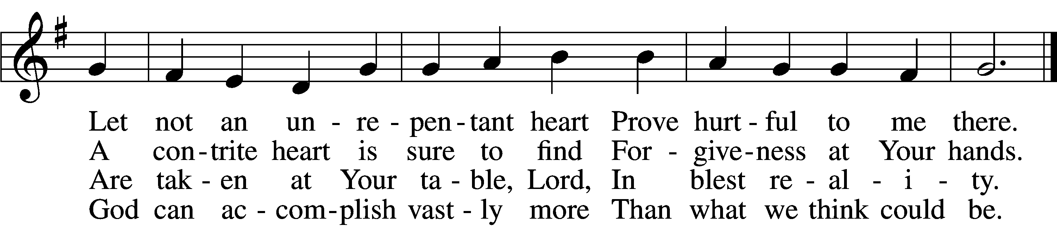

5 O grant, most blessèd Lord,
That earth and hell combined
May not about this sacrament
Raise doubt within my mind.

6 Oh, may I never fail
To thank You day and night
For Your true body and true blood,
O God, my peace and light.
Text and tune: Public domain

642 O Living Bread from Heaven
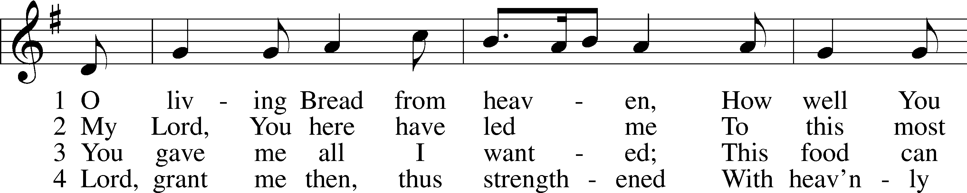
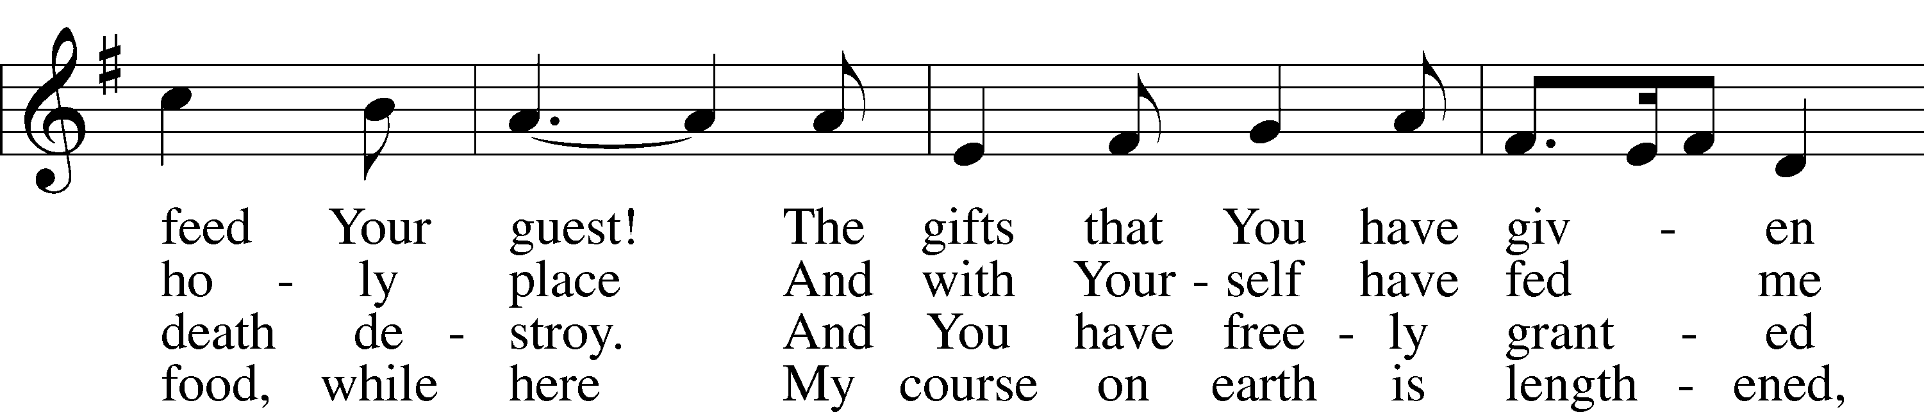
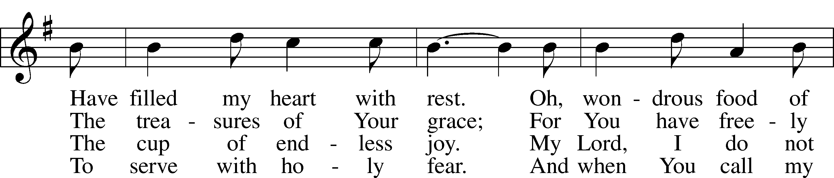
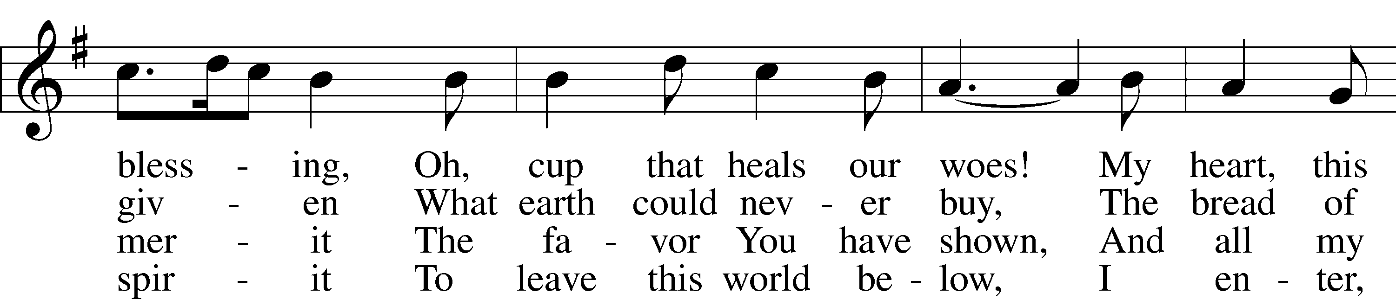
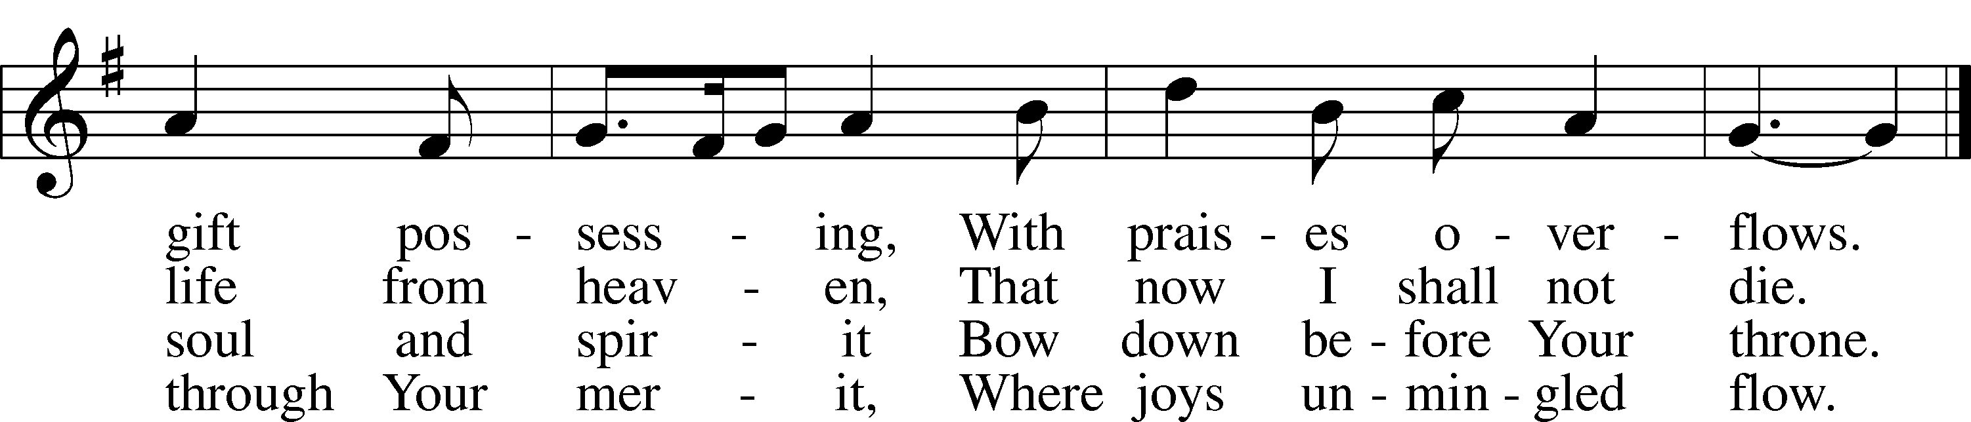
Tune and text: Public domain

670 Ye Watchers and Ye Holy Ones
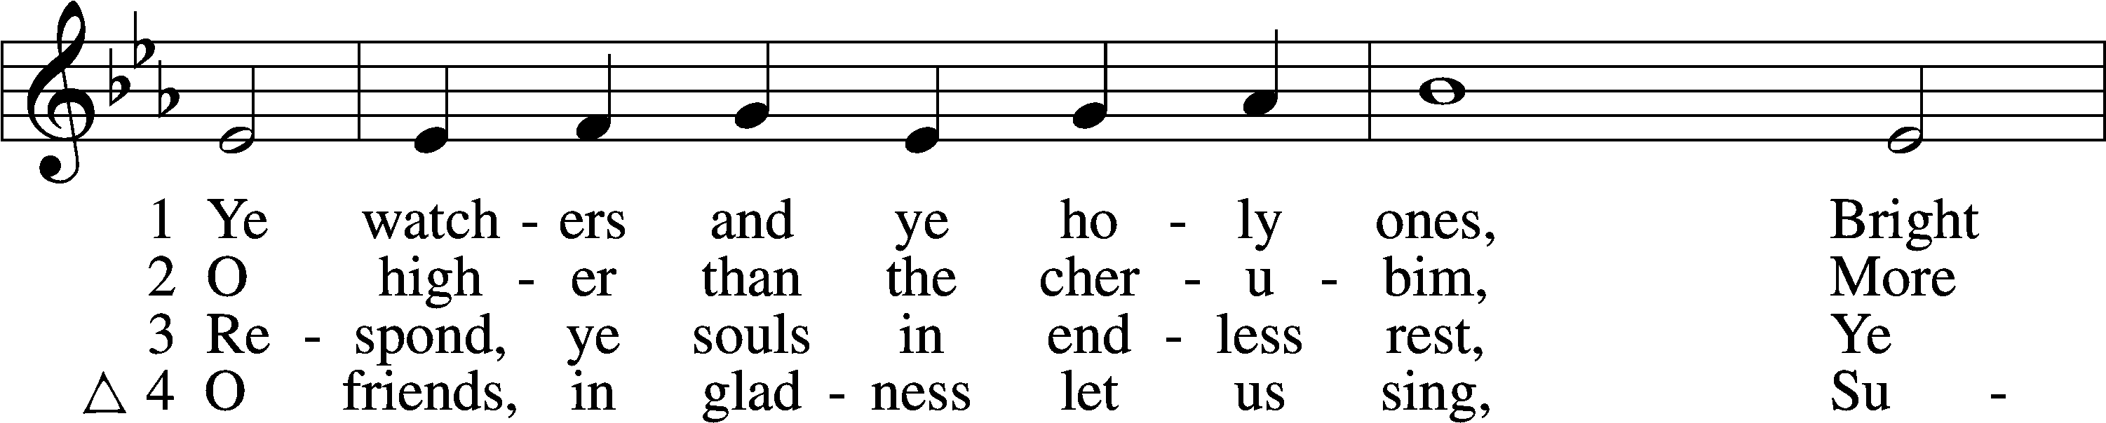
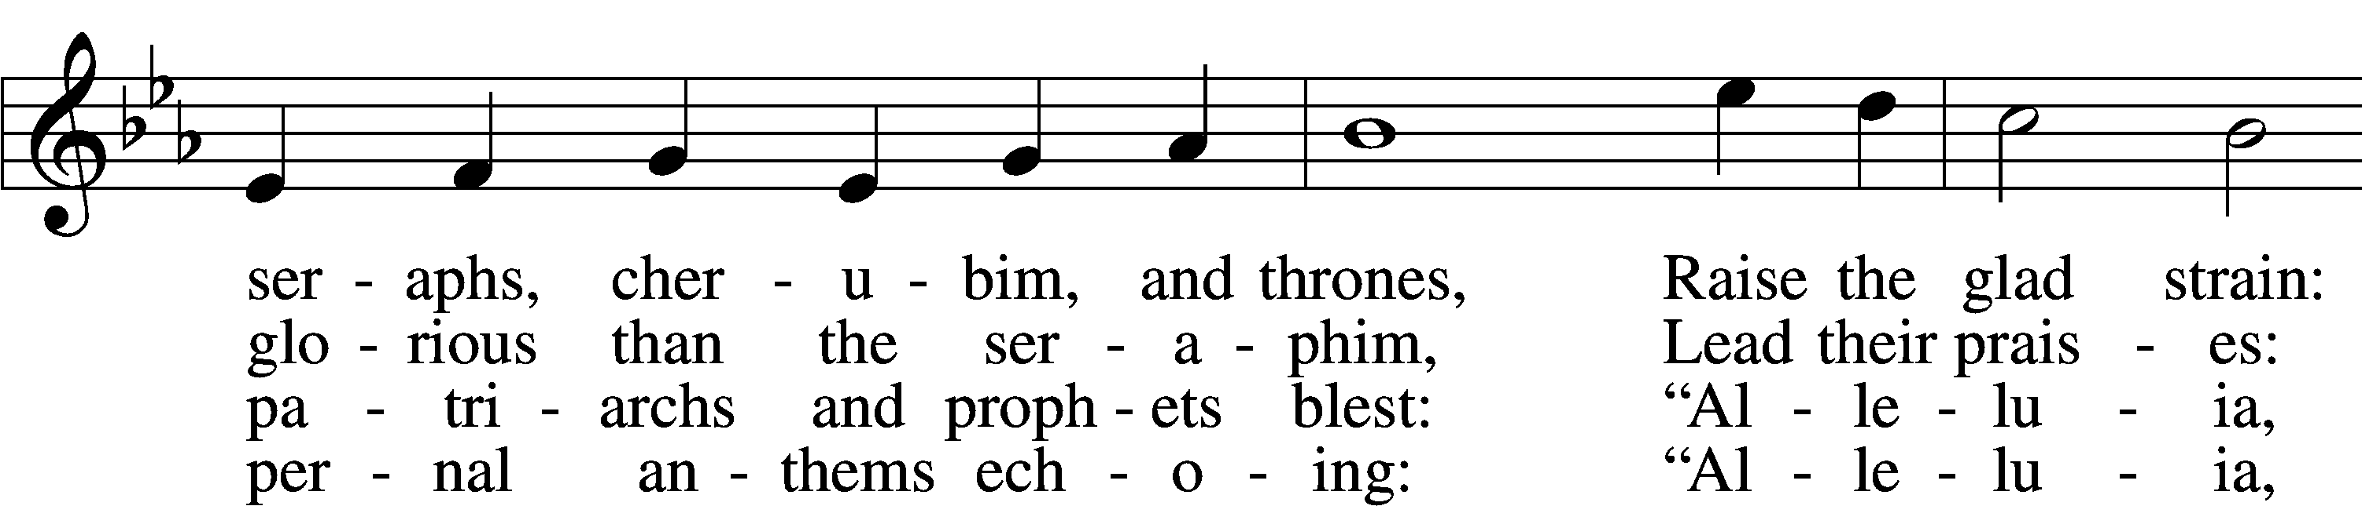
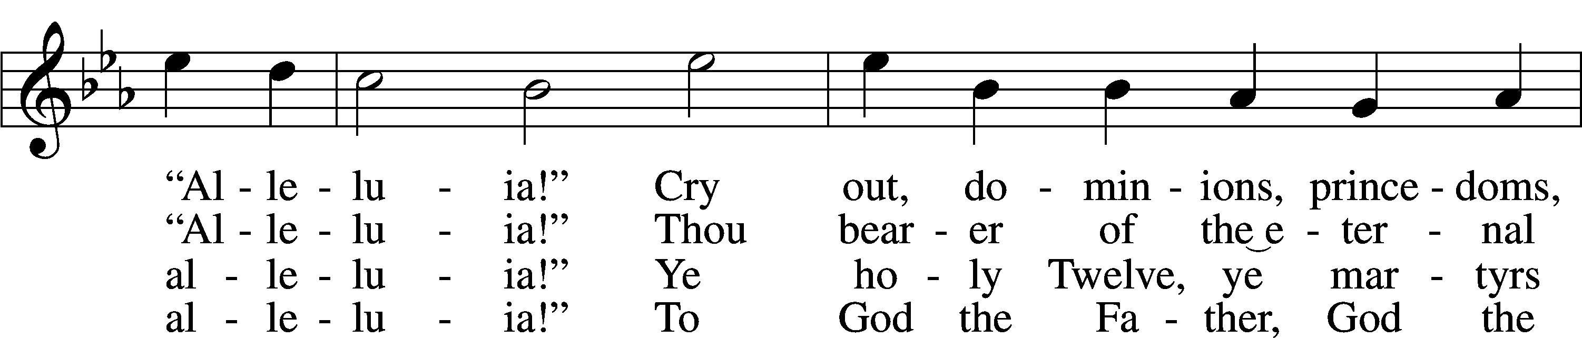
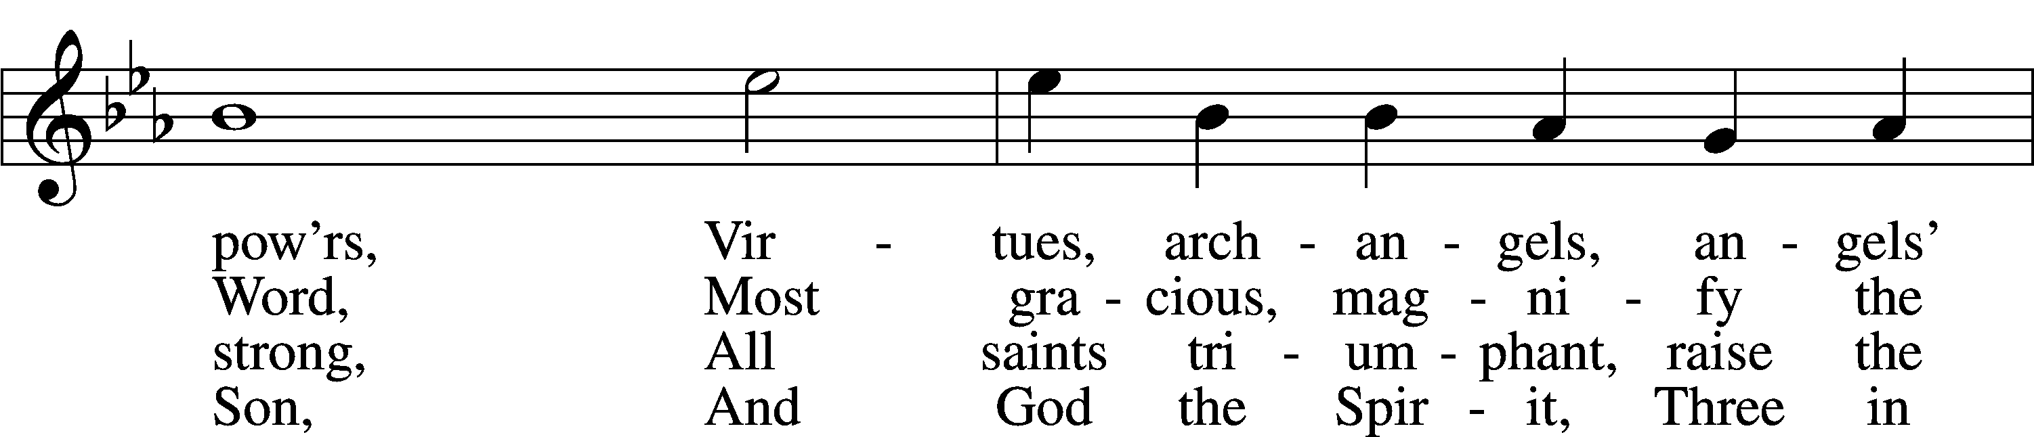
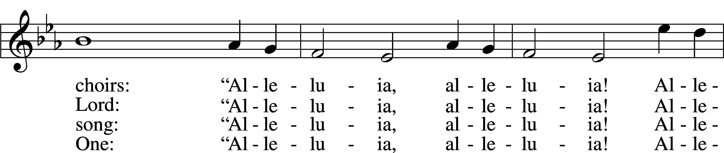
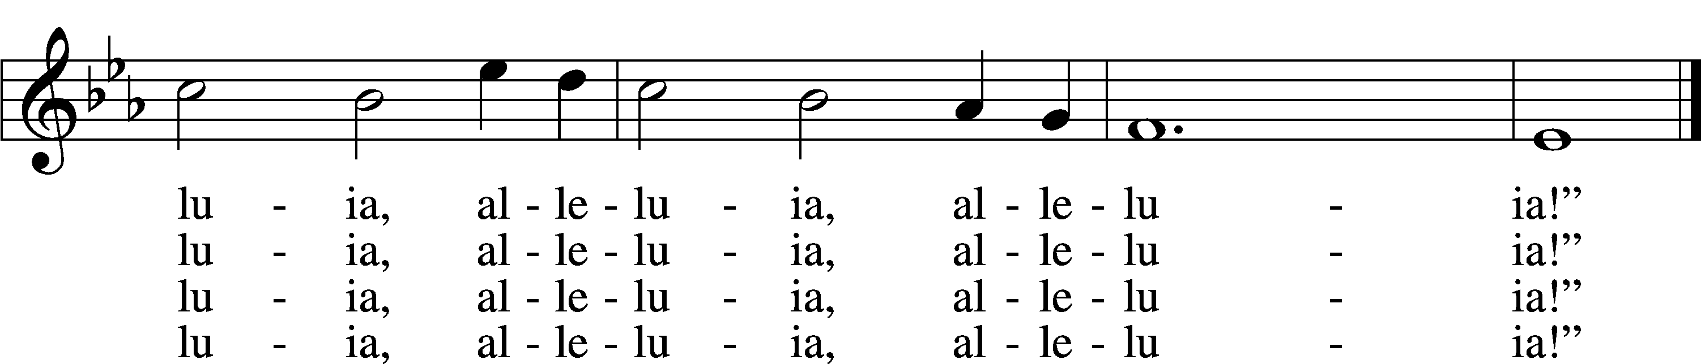
Tune and text: Public domain

Thank the Lord LSB 164
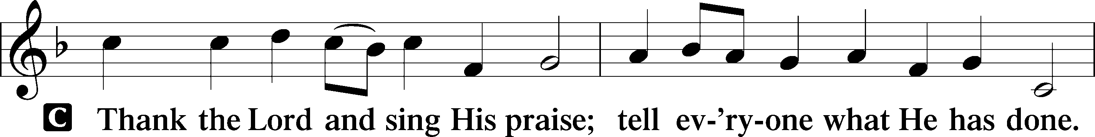
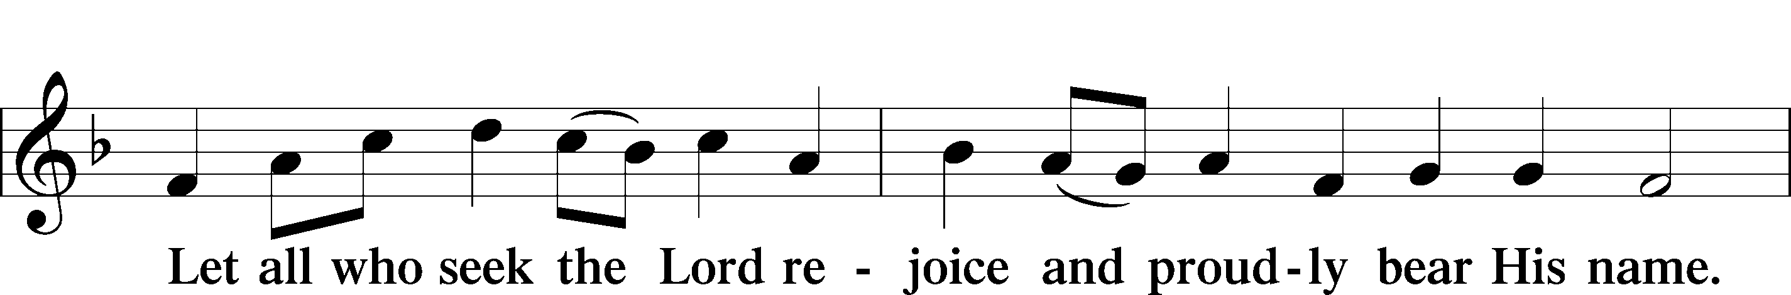
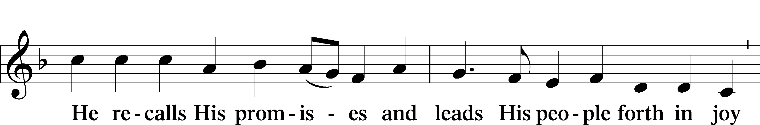
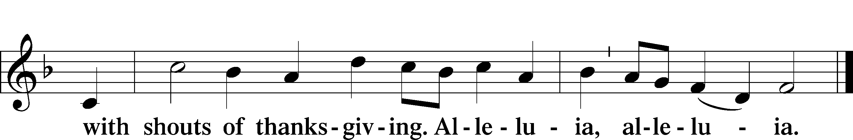

Post-Communion Collect
A Let us pray.
We give thanks to You, almighty God, that You have refreshed us through this salutary gift, and we implore You that of Your mercy You would strengthen us through the same in faith toward You and in fervent love toward one another; through Jesus Christ, Your Son, our Lord, who lives and reigns with You and the Holy Spirit, one God, now and forever.

Benediction LSB 166
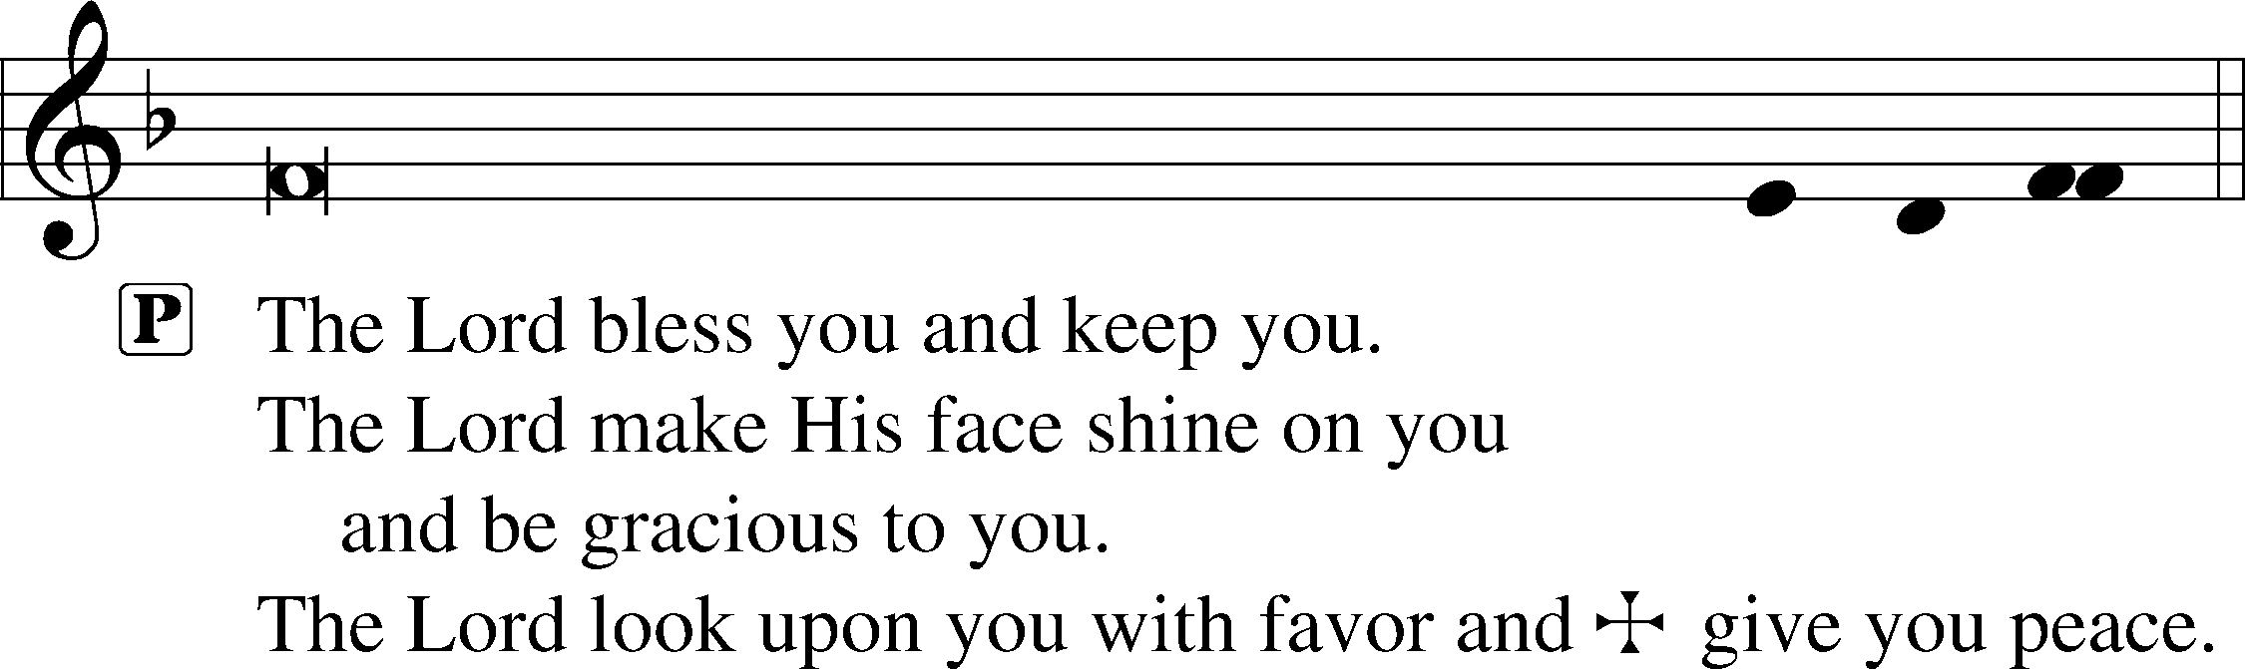

507 Holy, Holy, Holy
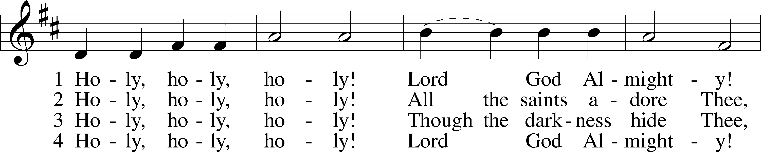
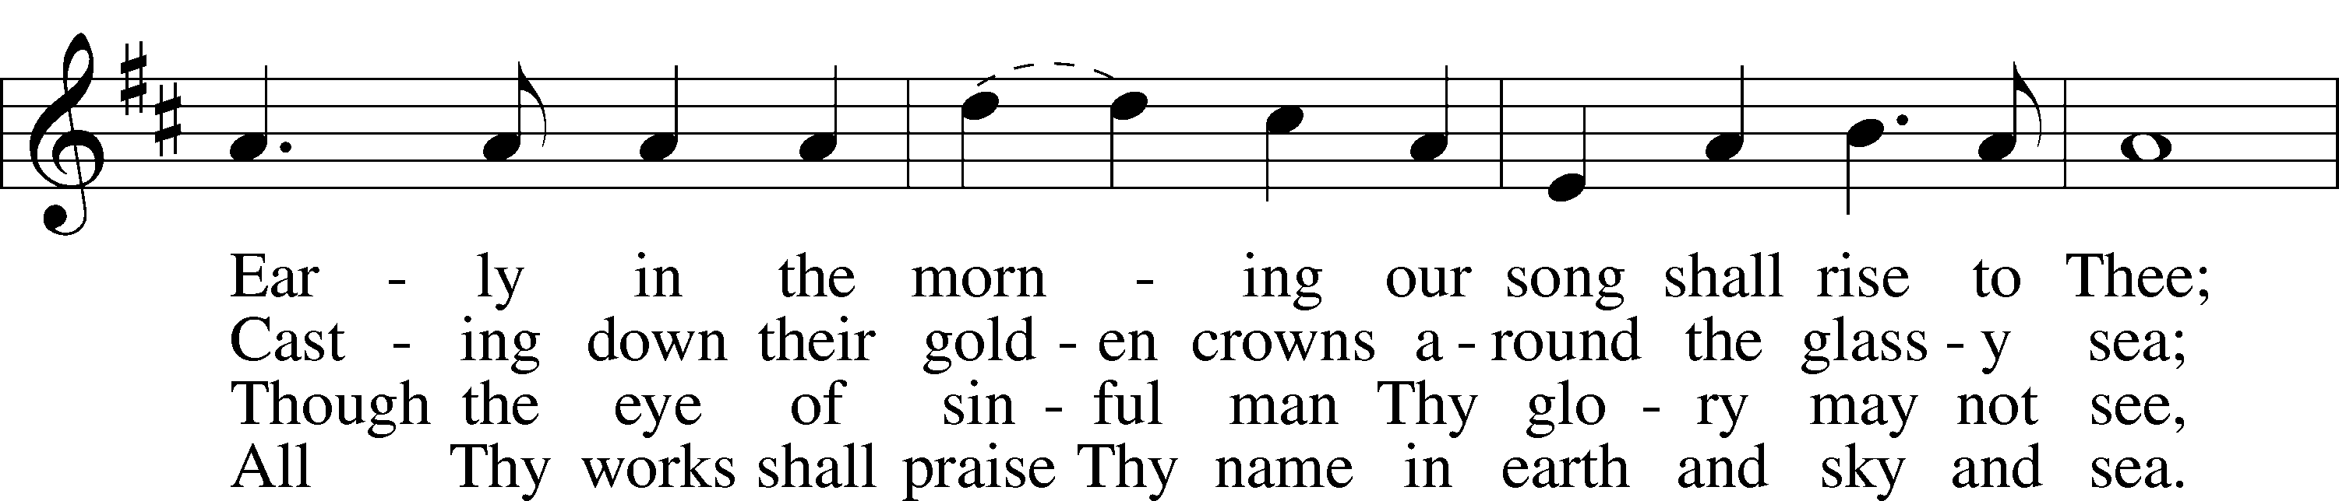
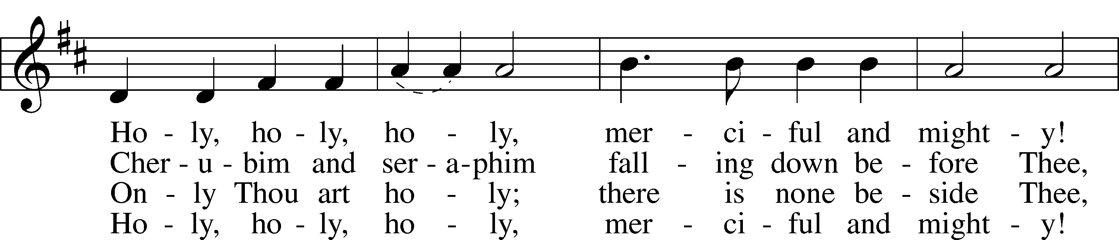
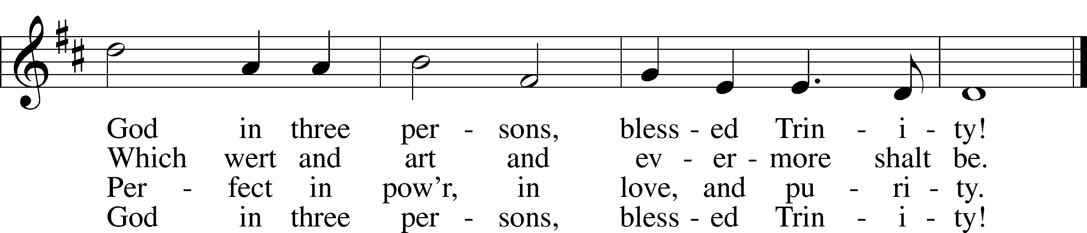
Text and tune: Public domain

Acknowledgments
Divine Service, Setting One from Lutheran Service Book
Unless otherwise indicated, Scripture quotations are from the ESV® Bible (The Holy Bible, English Standard Version®), copyright © 2001 by Crossway, a publishing ministry of Good News Publishers. Used by permission. All rights reserved.
Created by Lutheran Service Builder © 2021 Concordia Publishing House.

ANNOUNCEMENTS

Come join us for Bible Study today at 10:15 a.m. in the Fellowship Hall. We are studying the Gospel of Luke.

Sunday School is today at 10:15 a.m. at the Lutheran Student Center.

Thursday Noon Bible Study will meet in Fellowship Hall. We are studying the different Christian denominations.

Thank you, Carla Roedemeier & Sara McClelland, for providing altar care today.

Large print bulletins are now available. Please let an usher know if you need one.

Voter’s Meeting: June 13th at 1:00 pm in the nave.

Next Sunday, June 6 is LWML/DORCAS Mite Collection Sunday. The mite collection box will be located in the narthex before and after church service. Our mite offerings fund district and national mission projects of the LWML.

Please have any information you want in the bulletin for Sunday to the church secretary by 10:00/am Thursday.

We have a new church secretary Sue Nardi. Please stop in church office and say hello.

SUNDAY SCHOOL

“The King of Glory” is the title for this week’s lesson. King David prays, thanking God for His blessings & seeking His guidance. As David worships & acknowledges the true God, he asks God’s blessings on his household & nation. David’s psalm praises & glorifies God as it looks ahead to the coming of the glorious Savior & King.

