Fourth Sunday in Advent
December 20, 2020

Divine Service 3 Page 184

HYMN OF INVOCATION: 350 COME, THOU PRECIOUS RANSOM, COME

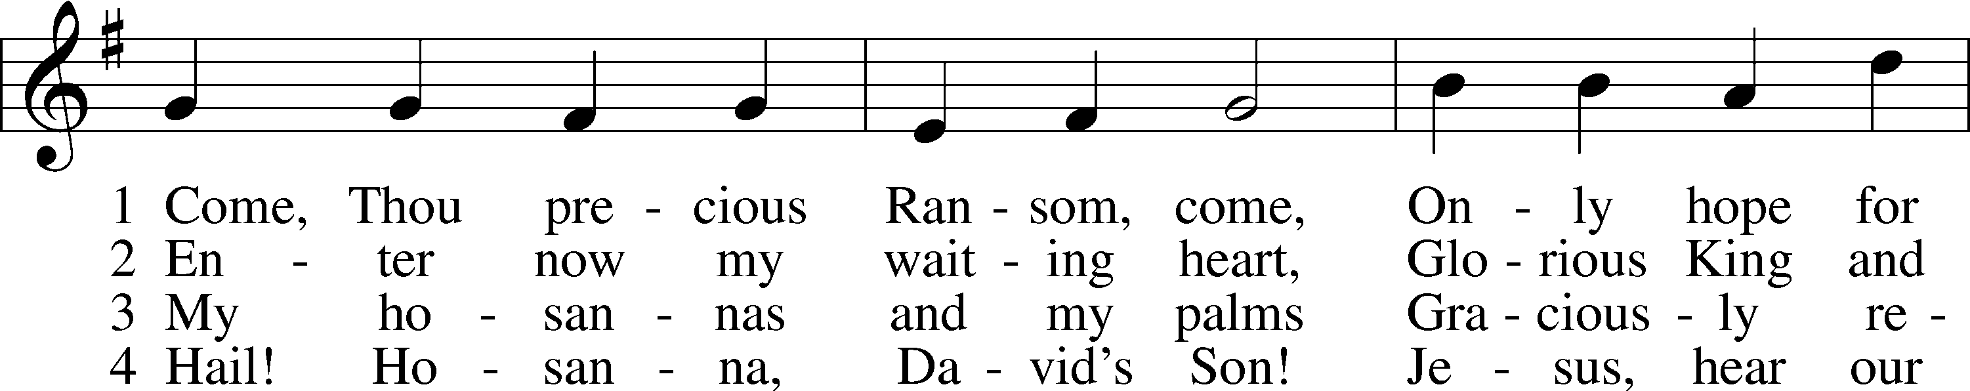
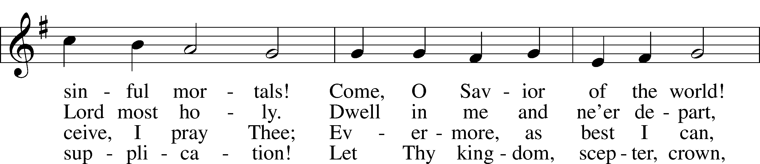
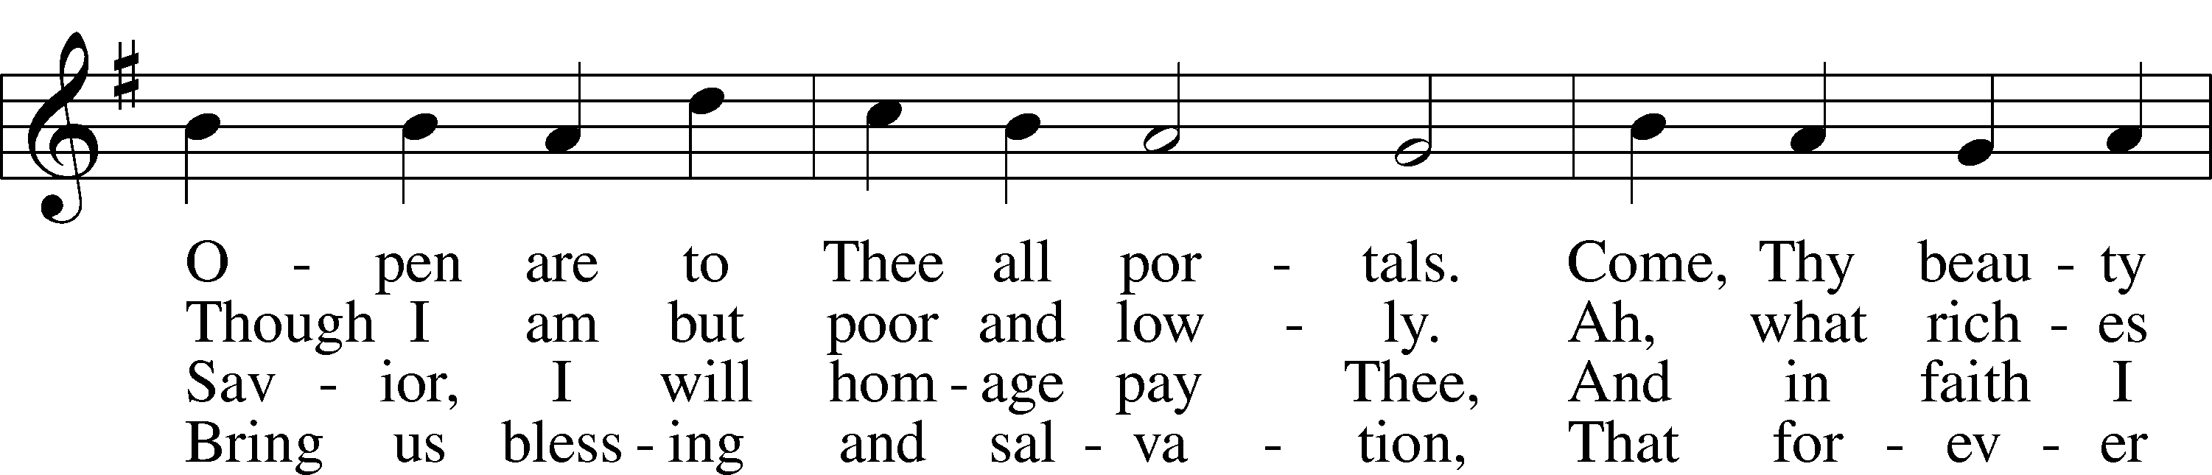
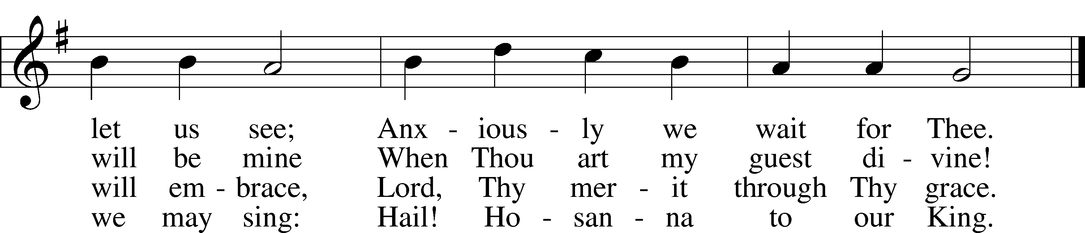
Text and tune: Public domain

P In the name of the Father and of the T Son and of the Holy Spirit.
C Amen.

P Beloved in the Lord! Let us draw near with a true heart and confess our sins unto God our Father, beseeching Him in the name of our Lord Jesus Christ to grant us forgiveness.

P Our help is in the name of the Lord,
C who made heaven and earth.
P I said, I will confess my transgressions unto the Lord,
C and You forgave the iniquity of my sin.

P O almighty God, merciful Father,
C I, a poor, miserable sinner, confess unto You all my sins and iniquities with which I have ever offended You and justly deserved Your temporal and eternal punishment. But I am heartily sorry for them and sincerely repent of them, and I pray You of Your boundless mercy and for the sake of the holy, innocent, bitter sufferings and death of Your beloved Son, Jesus Christ, to be gracious and merciful to me, a poor, sinful being.

P Upon this your confession, I, by virtue of my office, as a called and ordained servant of the Word, announce the grace of God unto all of you, and in the stead and by the command of my Lord Jesus Christ I forgive you all your sins in the name of the Father and of the T Son and of the Holy Spirit.
C Amen.

Service of the Word

INTROIT Psalm 19:1, 4c, 5–6; antiphon: Isaiah 45:8a, b

Shower, O heavens, from above, and let the clouds rain down | righteousness;*
let the earth open, that salvation and righteousness may | bear fruit.
The heavens declare the glory of God, and the sky above proclaims his | handiwork.*
In them he has set a tent | for the sun,
which comes out like a bridegroom leaving his | chamber,*
and, like a strong man, runs its | course with joy.
Its rising is from the end of the heavens, and its circuit to the | end of them,*
and there is nothing hidden | from its heat.
Glory be to the Father and | to the Son*
and to the Holy | Spirit;
as it was in the be- | ginning,*
is now, and will be forever. | Amen.
Shower, O heavens, from above, and let the clouds rain down | righteousness;*
let the earth open, that salvation and righteousness may | bear fruit.

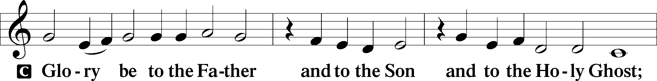
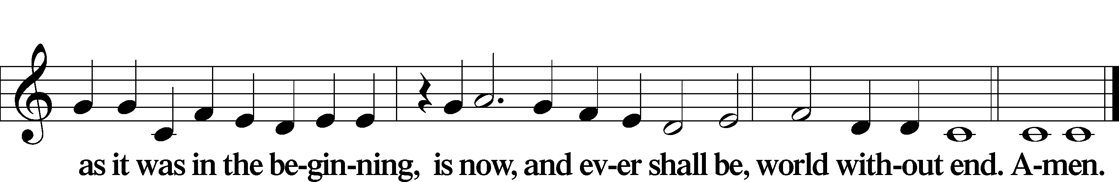

KYRIE LSB 186
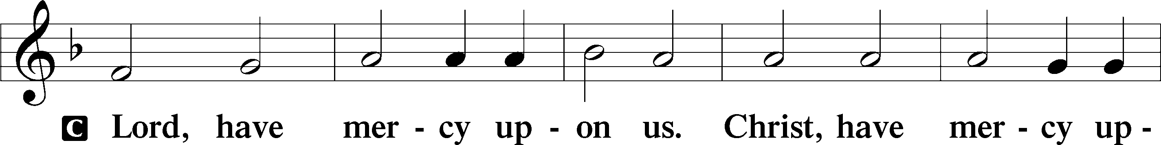
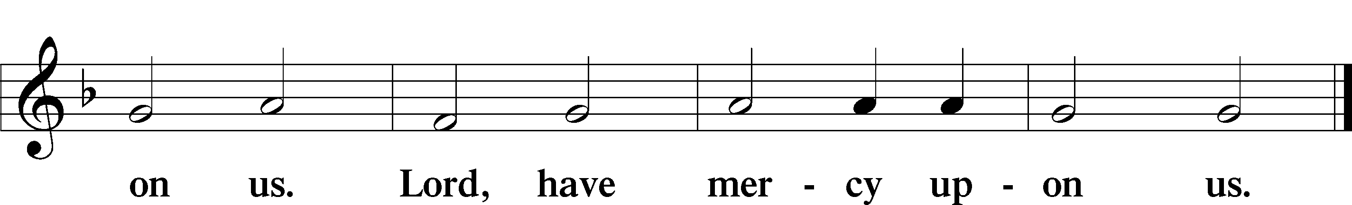

SALUTATION AND COLLECT OF THE DAY: ADVENT 4

P The Lord be with you.
C And with thy spirit.

P Let us pray.
Stir up Your power, O Lord, and come and help us by Your might, that the sins which weigh us down may be quickly lifted by Your grace and mercy; for You live and reign with the Father and the Holy Spirit, one God, now and forever.

C Amen.

Service of the Word

OLD TESTAMENT READING: 2 SAMUEL 7:1–11, 16 2 Samuel 7:1–11, 16

God’s Covenant with David
1Now when the king lived in his house and the Lord had given him rest from all his surrounding enemies, 2the king said to Nathan the prophet, “See now, I dwell in a house of cedar, but the ark of God dwells in a tent.” 3And Nathan said to the king, “Go, do all that is in your heart, for the Lord is with you.”
4But that same night the word of the Lord came to Nathan, 5“Go and tell my servant David, ‘Thus says the Lord: Would you build me a house to dwell in? 6I have not lived in a house since the day I brought up the people of Israel from Egypt to this day, but I have been moving about in a tent for my dwelling. 7In all places where I have moved with all the people of Israel, did I speak a word with any of the judges of Israel, whom I commanded to shepherd my people Israel, saying, “Why have you not built me a house of cedar?”’ 8Now, therefore, thus you shall say to my servant David, ‘Thus says the Lord of hosts, I took you from the pasture, from following the sheep, that you should be prince over my people Israel. 9And I have been with you wherever you went and have cut off all your enemies from before you. And I will make for you a great name, like the name of the great ones of the earth. 10And I will appoint a place for my people Israel and will plant them, so that they may dwell in their own place and be disturbed no more. And violent men shall afflict them no more, as formerly, 11from the time that I appointed judges over my people Israel. And I will give you rest from all your enemies. Moreover, the Lord declares to you that the Lord will make you a house. . . .
16And your house and your kingdom shall be made sure forever before me. Your throne shall be established forever.’”

A This is the Word of the Lord.
C Thanks be to God.

EPISTLE: ROMANS 16:25–27 Romans 16:25–27

Doxology
25Now to him who is able to strengthen you according to my gospel and the preaching of Jesus Christ, according to the revelation of the mystery that was kept secret for long ages 26but has now been disclosed and through the prophetic writings has been made known to all nations, according to the command of the eternal God, to bring about the obedience of faith— 27to the only wise God be glory forevermore through Jesus Christ! Amen.

A This is the Word of the Lord.
C Thanks be to God.

ALLELUIA LSB 190
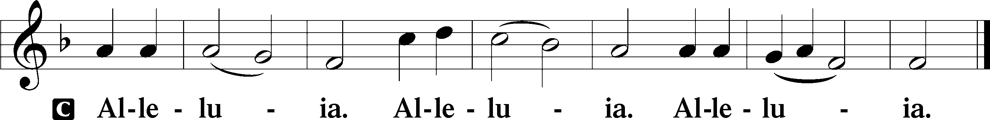

HOLY GOSPEL: LUKE 1:26–38 Luke 1:26–38

P The Holy Gospel according to St. Luke, the first chapter.
C Glory be to Thee, O Lord.

Birth of Jesus Foretold

26In the sixth month the angel Gabriel was sent from God to a city of Galilee named Nazareth, 27to a virgin betrothed to a man whose name was Joseph, of the house of David. And the virgin’s name was Mary. 28And he came to her and said, “Greetings, O favored one, the Lord is with you!” 29But she was greatly troubled at the saying, and tried to discern what sort of greeting this might be. 30And the angel said to her, “Do not be afraid, Mary, for you have found favor with God. 31And behold, you will conceive in your womb and bear a son, and you shall call his name Jesus. 32He will be great and will be called the Son of the Most High. And the Lord God will give to him the throne of his father David, 33and he will reign over the house of Jacob forever, and of his kingdom there will be no end.”
34And Mary said to the angel, “How will this be, since I am a virgin?”
35And the angel answered her, “The Holy Spirit will come upon you, and the power of the Most High will overshadow you; therefore the child to be born will be called holy—the Son of God. 36And behold, your relative Elizabeth in her old age has also conceived a son, and this is the sixth month with her who was called barren. 37For nothing will be impossible with God.” 38And Mary said, “Behold, I am the servant of the Lord; let it be to me according to your word.” And the angel departed from her.

P This is the Gospel of the Lord.
C Praise be to Thee, O Christ.

APOSTLES’ CREED

C I believe in God, the Father Almighty,
maker of heaven and earth.

And in Jesus Christ, His only Son, our Lord,
who was conceived by the Holy Spirit,
born of the virgin Mary,
suffered under Pontius Pilate,
was crucified, died and was buried.
He descended into hell.
The third day He rose again from the dead.
He ascended into heaven
and sits at the right hand of God the Father Almighty.
From thence He will come to judge the living and the dead.

I believe in the Holy Spirit,
the holy Christian Church,
the communion of saints,
the forgiveness of sins,
the resurrection of the body,
and the life T everlasting. Amen.

HYMN OF THE DAY: 341 LIFT UP YOUR HEADS, YE MIGHTY GATES
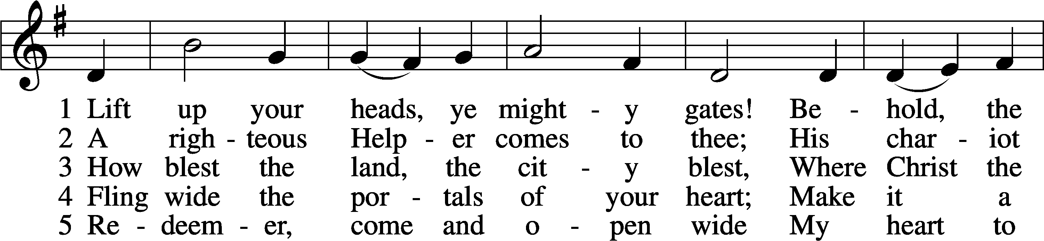
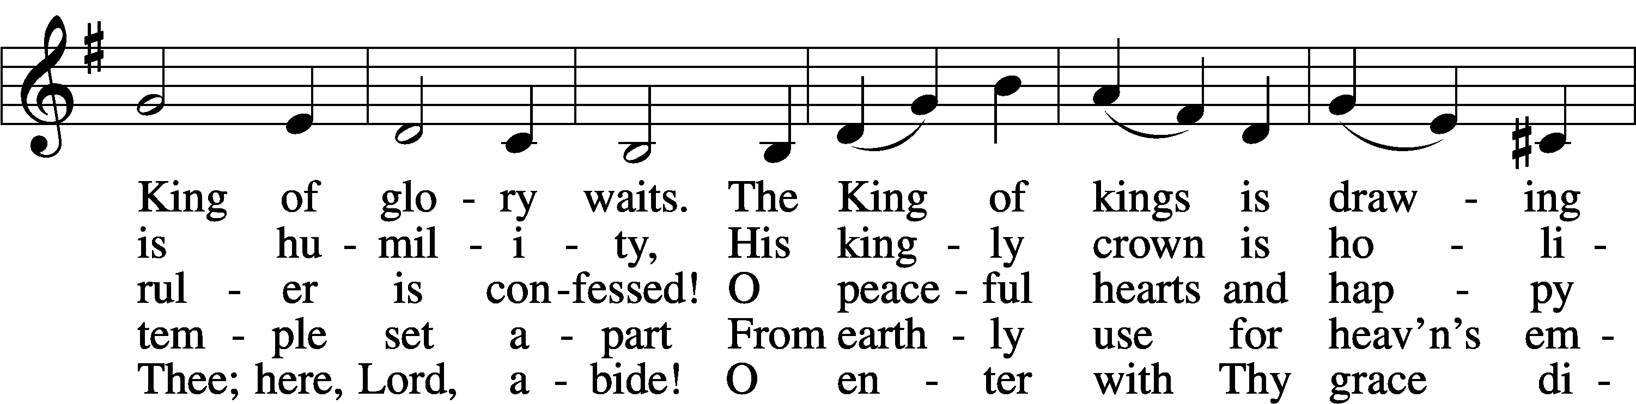
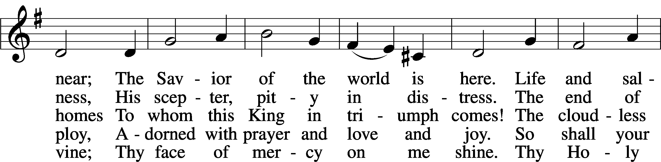
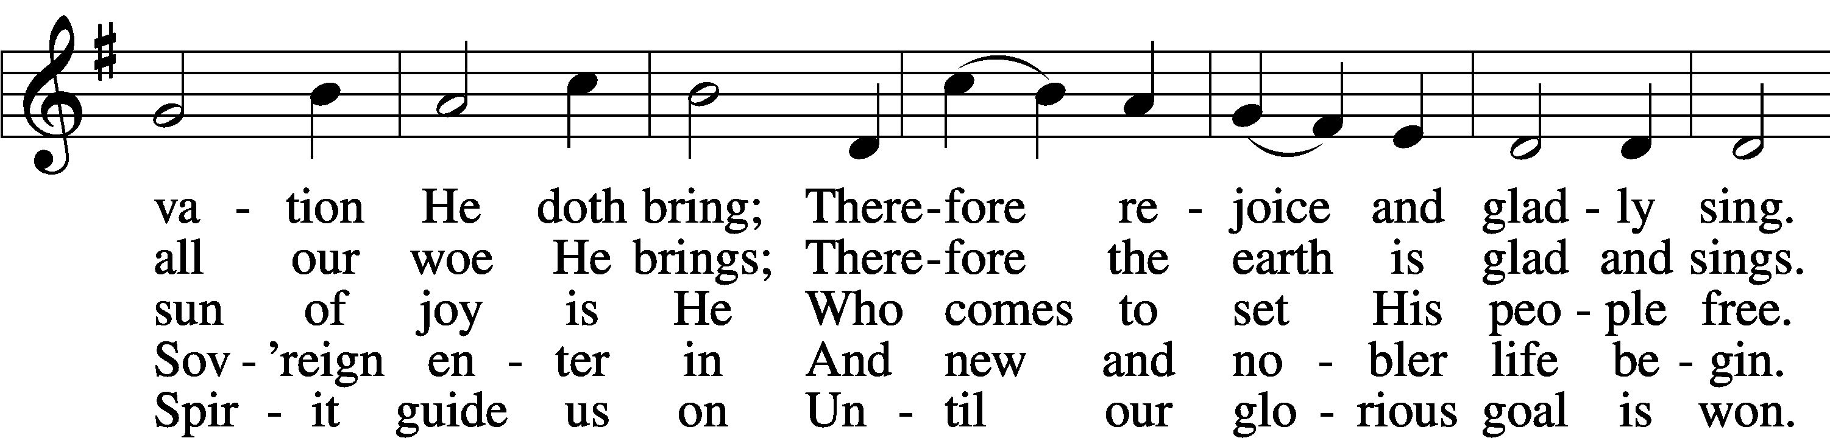
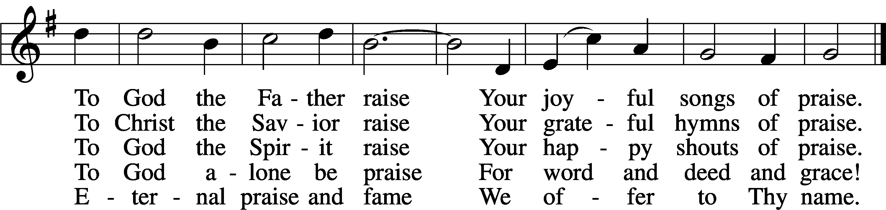
Tune and text: Public domain

SERMON

P The peace of God, which passes all understanding, keep your hearts and minds in Christ Jesus.
C Amen.

OFFERTORY LSB 192
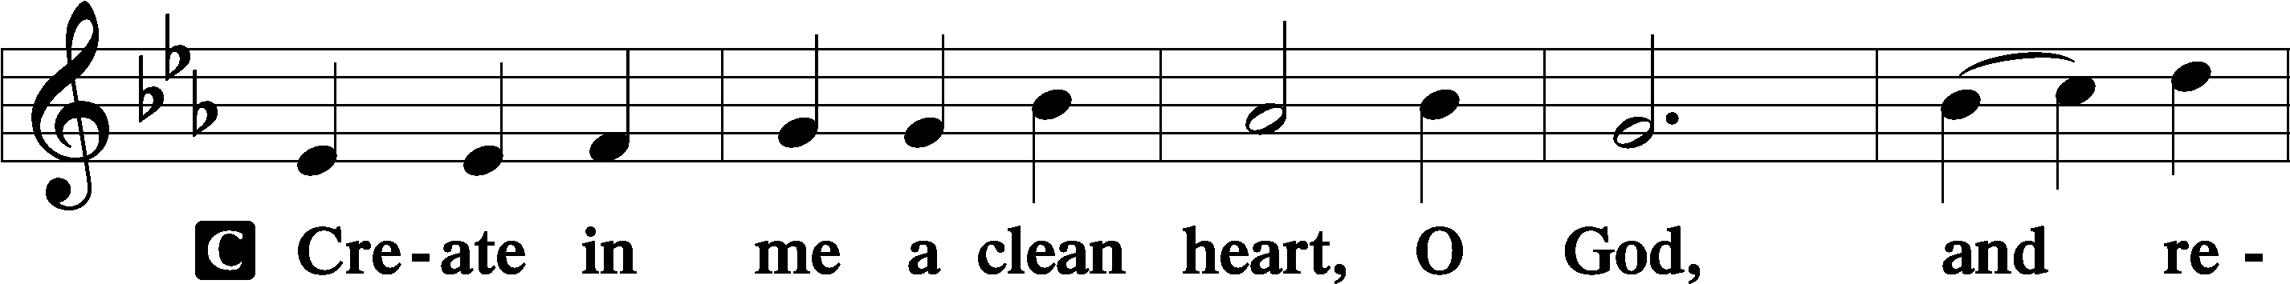
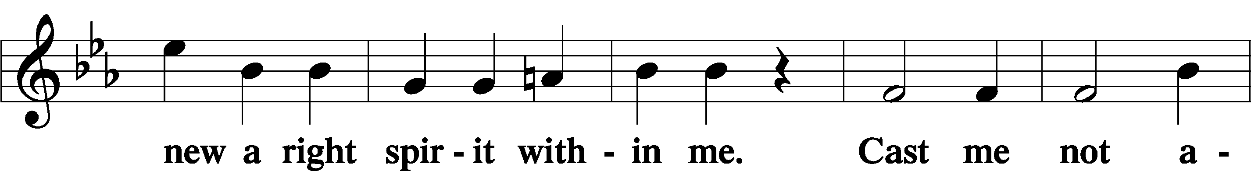
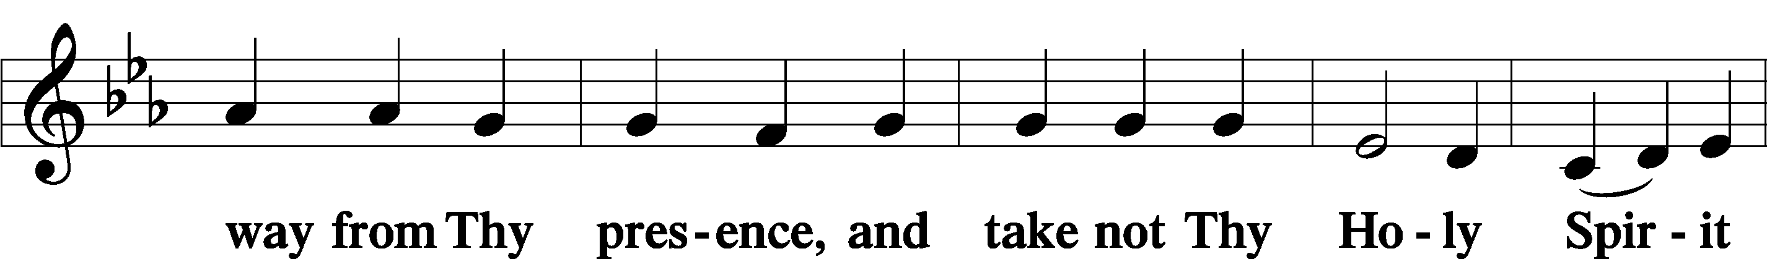
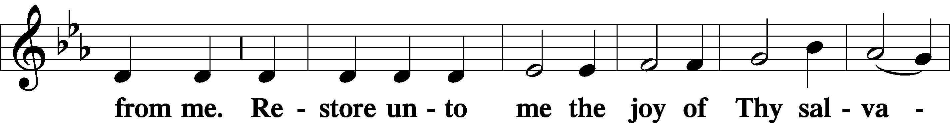
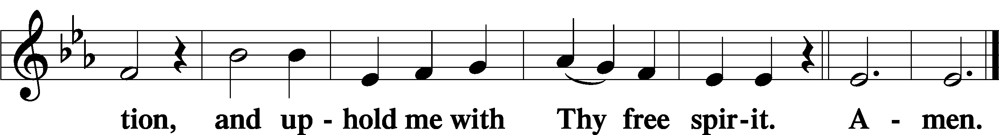

OFFERING

PRAYER OF THE CHURCH
P In peace, let us pray to the Lord:
C Lord, have mercy.

Brief silence

P In thanksgiving to God for the favor shown us in Christ and His incarnation; for faith to believe that nothing is impossible with Him; and that everything would be to us according to the Word of the Most High, let us pray to the Lord:
C Lord, have mercy.

P For faithful preachers of Your Gospel to bring about the obedience of faith by the mystery of Christ now revealed in the prophetic and apostolic Scriptures; for Matthew, our Synod president; _____________, our district president; and _____________, our circuit visitor; and for the Holy Christian Church, that God would strengthen it in every place, let us pray to the Lord:
C Lord, have mercy.

P For our nation, its president, all legislators and judges, and those newly elected to serve, that God would preserve their lives and guide their actions for the good of our people; for peace among the nations of the earth, and that God would preserve us from pestilence and famine, war and bloodshed, sedition, rebellion and every evil, let us pray to the Lord:
C Lord, have mercy.

P For all women with child and all mothers with infant children, that God would grant them increasing happiness in their blessings [especially _____________]; for the lonely, the depressed and the despairing; for the sick, the anxious and the dying [especially _____________]; and for those who mourn [the death of _____________], that they would take comfort in the resurrection, let us pray to the Lord:
C Lord, have mercy.

P For all who receive Christ’s holy body and precious blood today, that they may eat and drink it in repentance and faith and in the unity of a true confession; and for a love and desire for the blessed Sacrament this Christmas, let us pray to the Lord:
C Lord, have mercy.

P O Most High, we give You thanks for Your Son, our Lord Jesus Christ, who is the Key of David and the scepter of the house of Israel. By His death, He has opened the kingdom of heaven and closed the gates of hell for all who trust in Him. By His resurrection, He has rescued the prisoners who sat in darkness and in the shadow of death. Grant that, as we recall with thanksgiving His advent in the flesh, we may always confess Him and remain watchful for His advent in glory at the Last Day; through the same Jesus Christ, Your Son, our Lord, who lives and reigns with You and the Holy Spirit, one God, now and forever.
C Amen.

Service of the Sacrament

PREFACE LSB 194
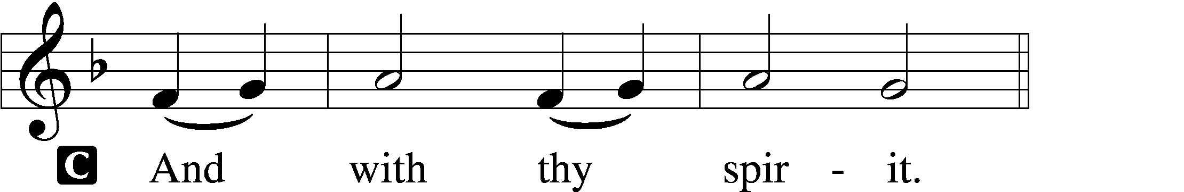

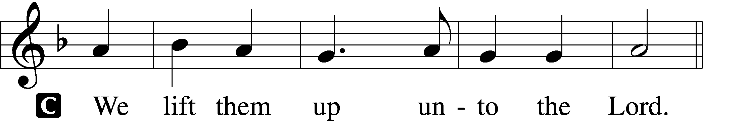

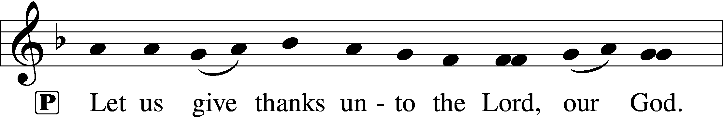
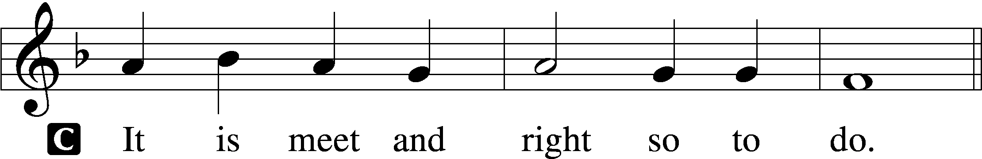

P It is truly meet, right, and salutary that we should at all times and in all places give thanks to You, holy Lord, almighty Father, everlasting God, through Jesus Christ, our Lord, whose way John the Baptist prepared, proclaiming Him the promised Messiah, the very Lamb of God who takes away the sin of the world, and calling sinners to repentance that they might escape from the wrath to be revealed when He comes again in glory. Therefore with angels and archangels and with all the company of heaven we laud and magnify Your glorious name, evermore praising You and saying:

SANCTUS LSB 195
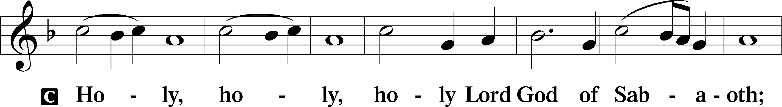
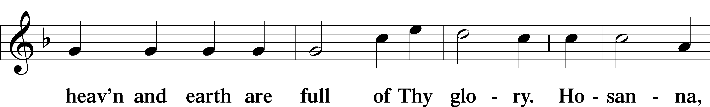
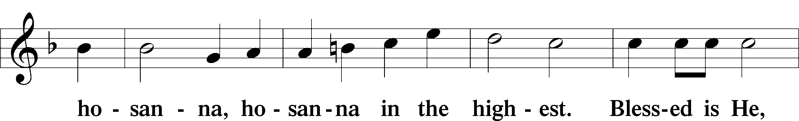
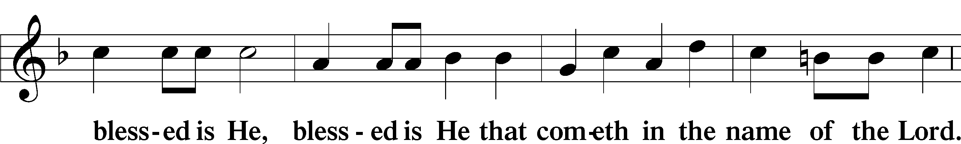
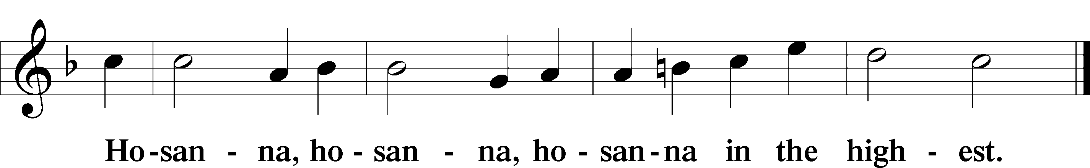

LORD’S PRAYER 196
P Our Father who art in heaven,
hallowed be Thy name,
Thy kingdom come,
Thy will be done on earth as it is in heaven;
give us this day our daily bread;
and forgive us our trespasses as we forgive those who trespass against us;
and lead us not into temptation,
but deliver us from evil.
C For Thine is the kingdom and the power and the glory forever and ever. Amen.

THE WORDS OF OUR LORD LSB 197
P Our Lord Jesus Christ, on the night when He was betrayed, took bread, and when He had given thanks, He broke it and gave it to the disciples and said: “Take, eat; this is My T body, which is given for you. This do in remembrance of Me.”

In the same way also He took the cup after supper, and when He had given thanks, He gave it to them, saying: “Drink of it, all of you; this cup is the new testament in My T blood, which is shed for you for the forgiveness of sins. This do, as often as you drink it, in remembrance of Me.”

PAX DOMINI LSB 197
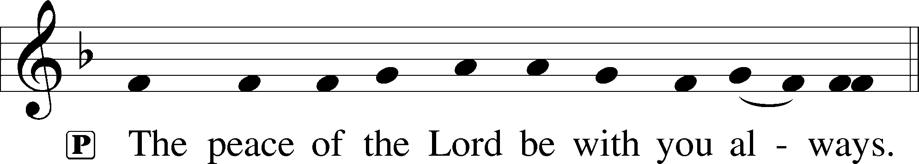

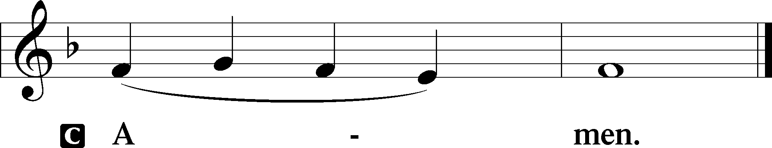

AGNUS DEI LSB 198
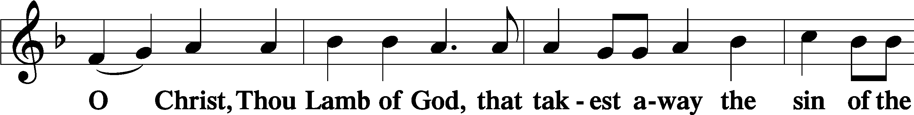
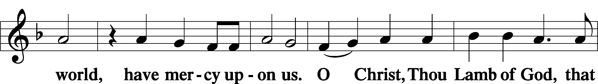
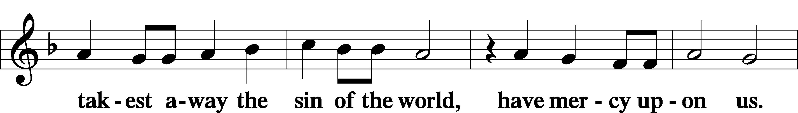
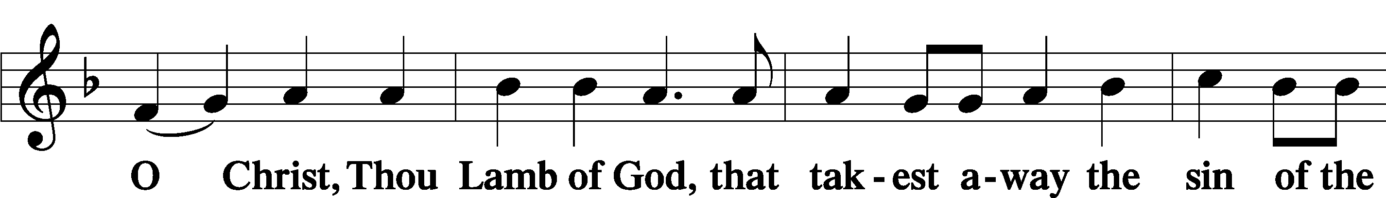
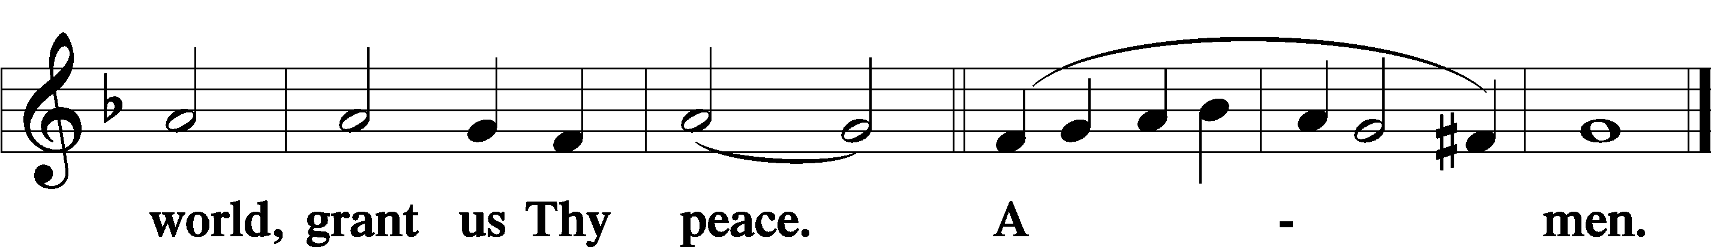

DISTRIBUTION

DISTRIBUTION HYMN: 349 HARK THE GLAD SOUND
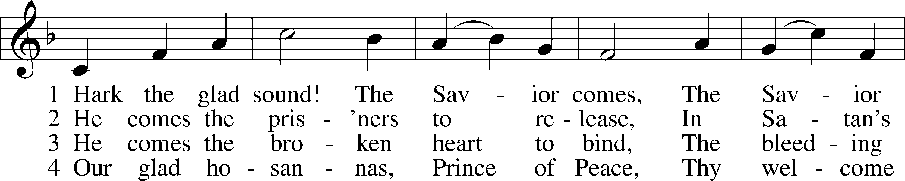
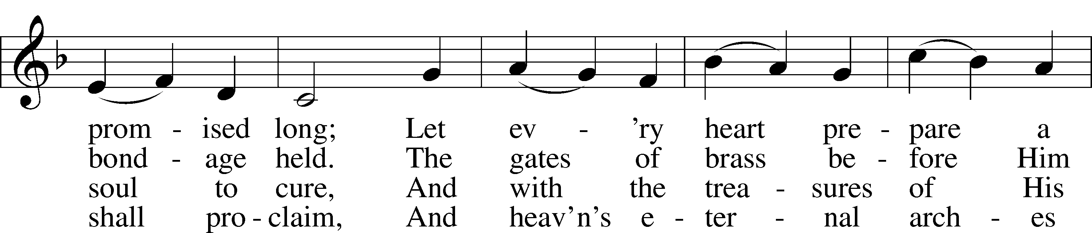
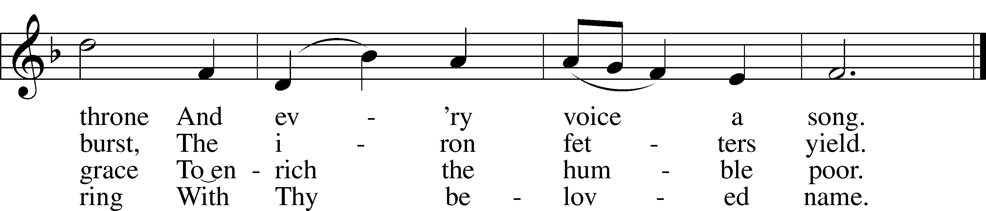
Tune and text: Public domain

DISTRIBUTION HYMN: 357 O COME, O COME, EMMANUEL
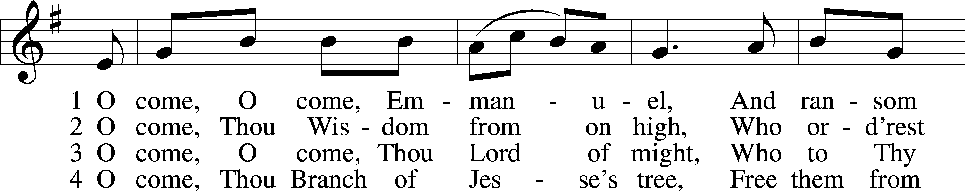
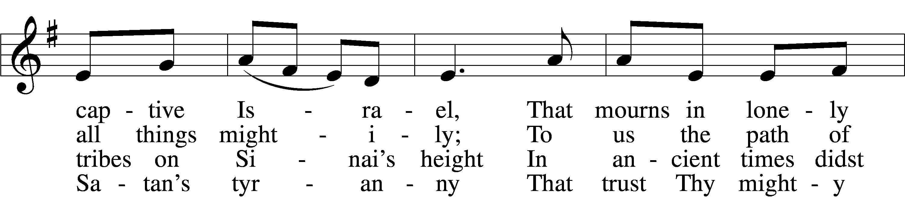
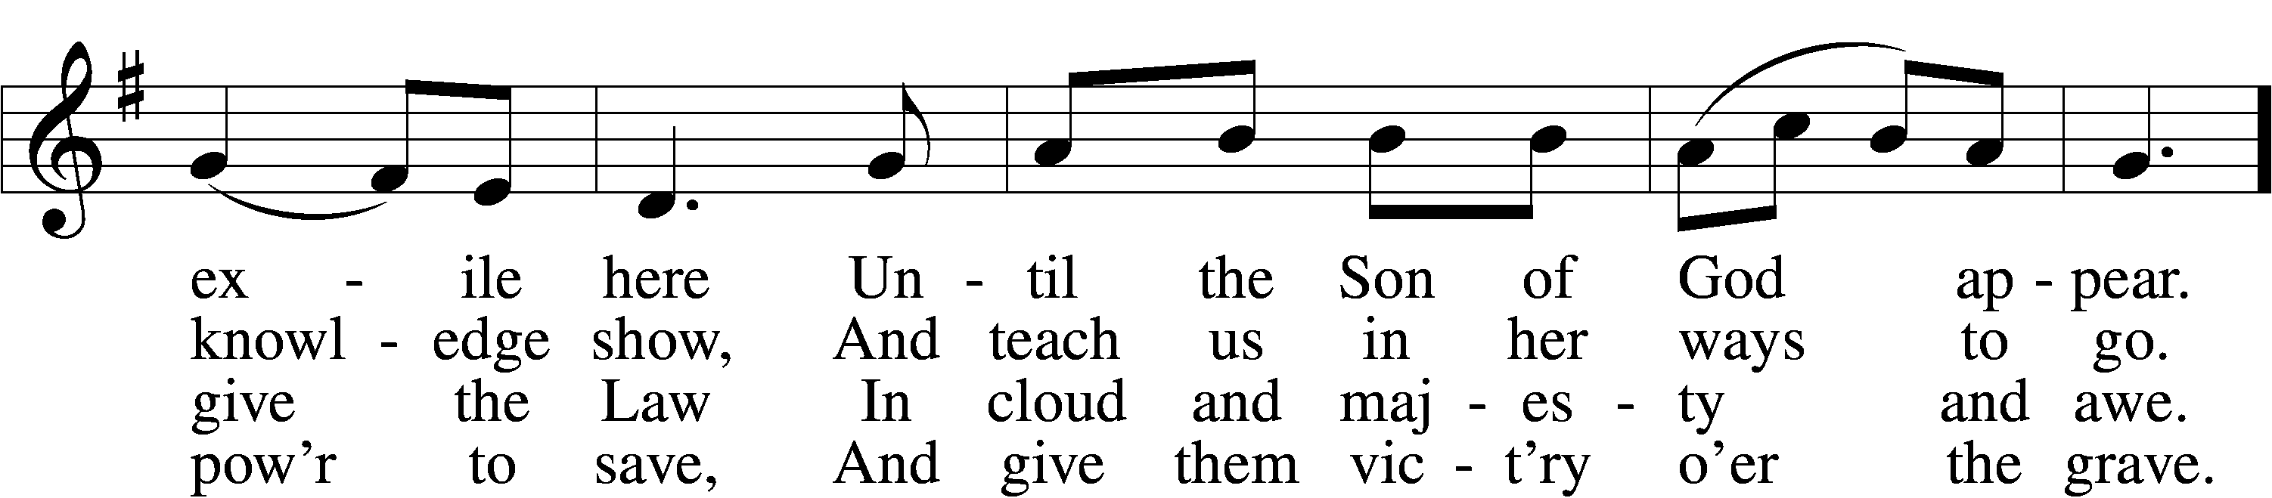
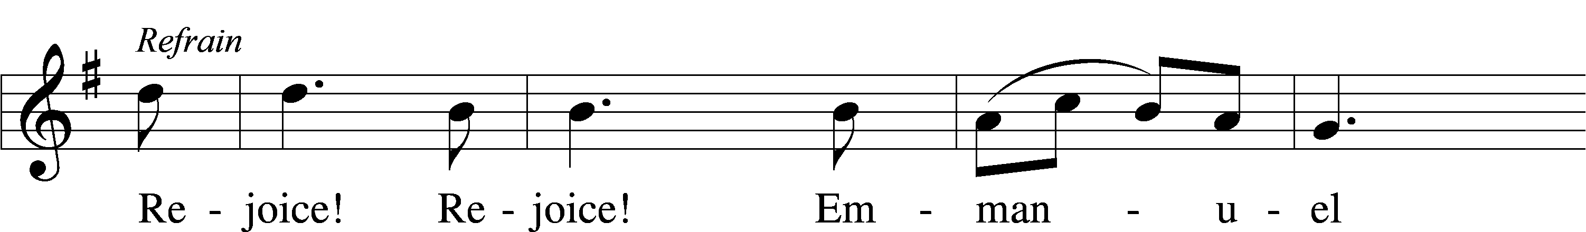
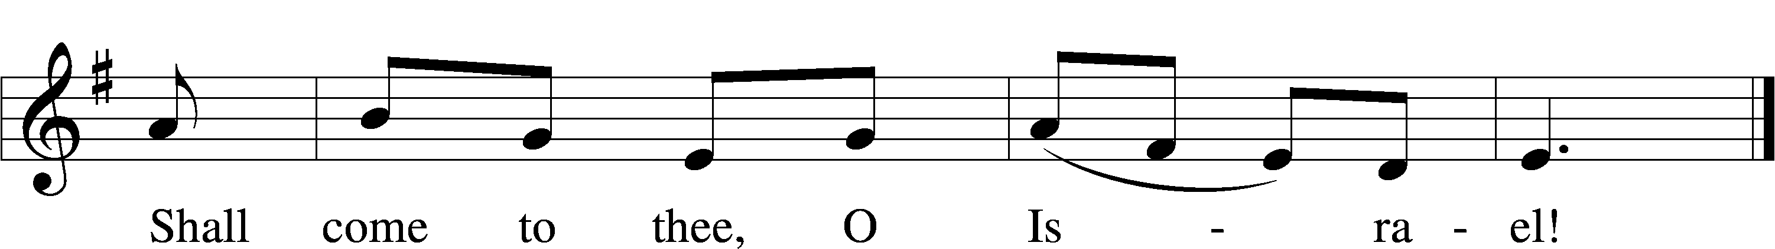

5 O come, Thou Key of David, come,
And open wide our heav’nly home;
Make safe the way that leads on high,
And close the path to misery. Refrain

6 O come, Thou Dayspring from on high,
And cheer us by Thy drawing nigh;
Disperse the gloomy clouds of night,
And death’s dark shadows put to flight. Refrain

7 O come, Desire of nations, bind
In one the hearts of all mankind;
Bid Thou our sad divisions cease,
And be Thyself our King of Peace. Refrain
Tune and text: Public domain

NUNC DIMITTIS LSB 199
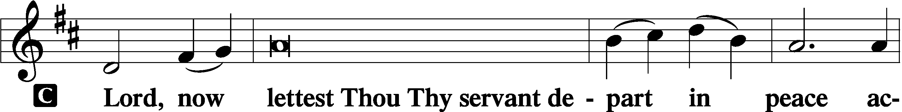

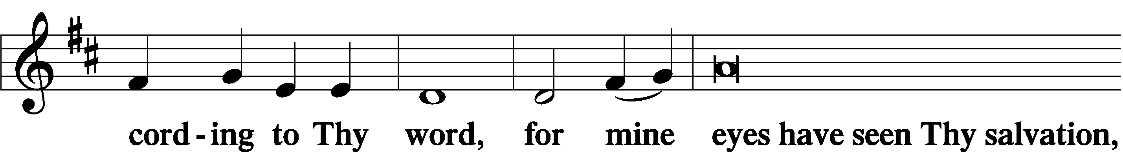

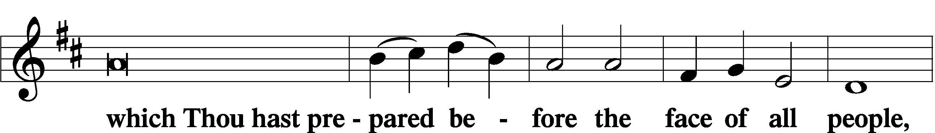

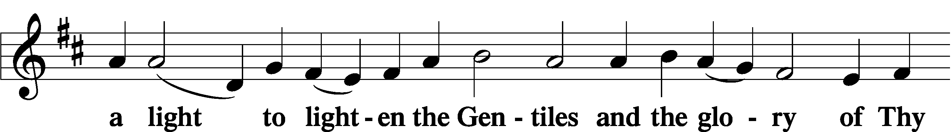

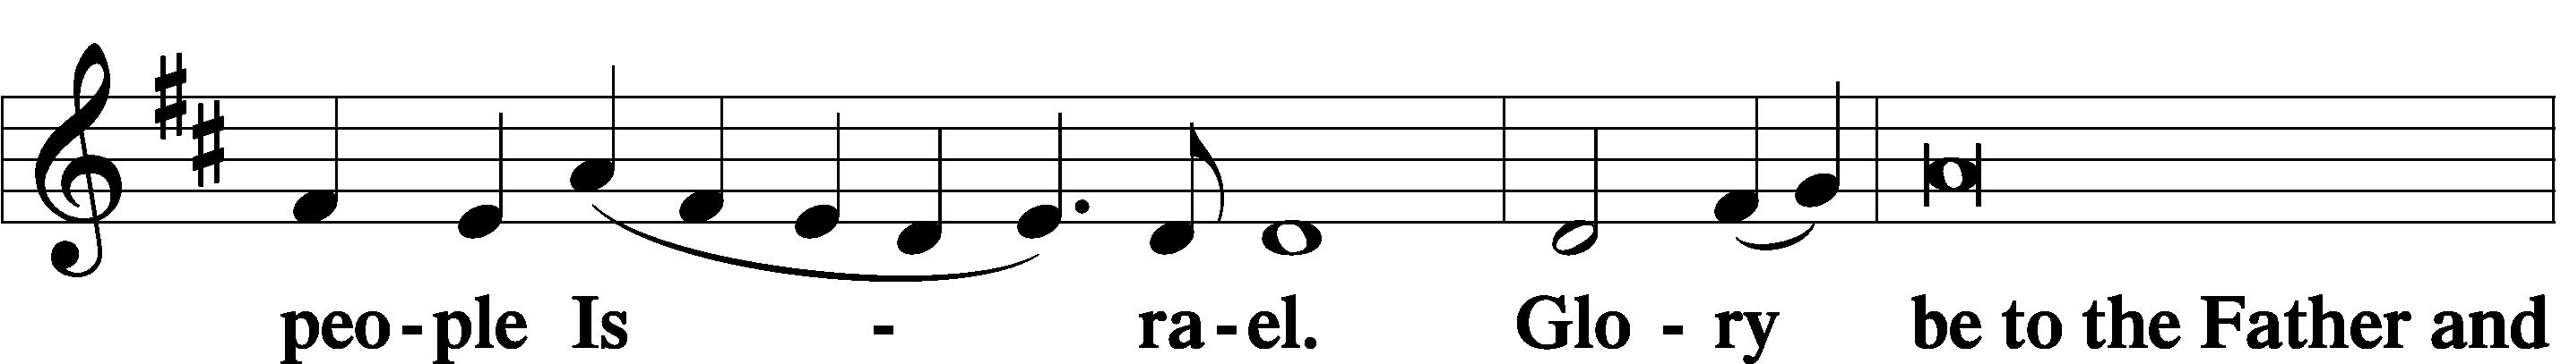

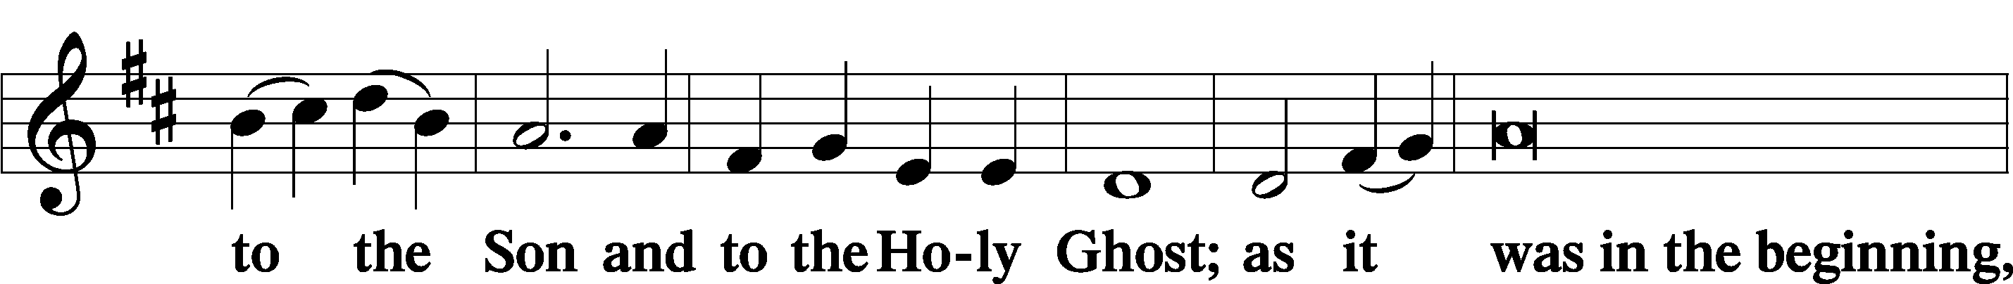

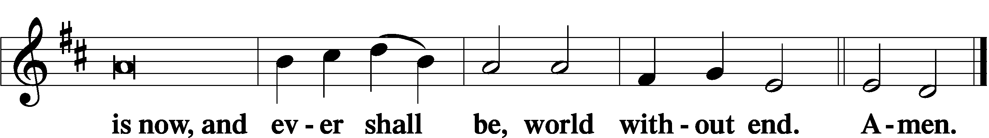

THANKSGIVING LSB 200
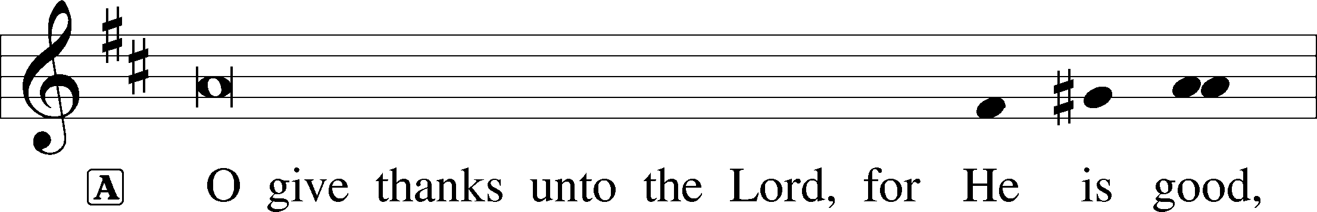

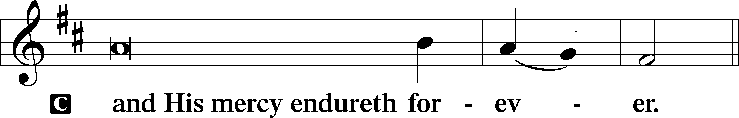

A Let us pray.
We give thanks to You, almighty God, that You have refreshed us through this salutary gift, and we implore You that of Your mercy You would strengthen us through the same in faith toward You and in fervent love toward one another; through Jesus Christ, Your Son, our Lord, who lives and reigns with You and the Holy Spirit, one God, now and forever.

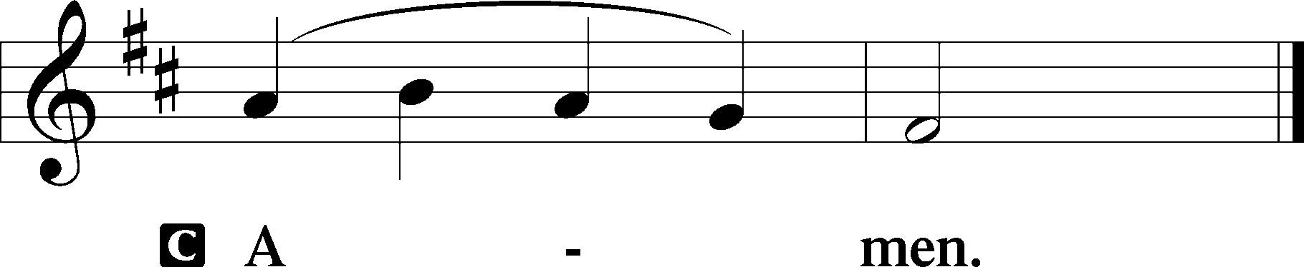

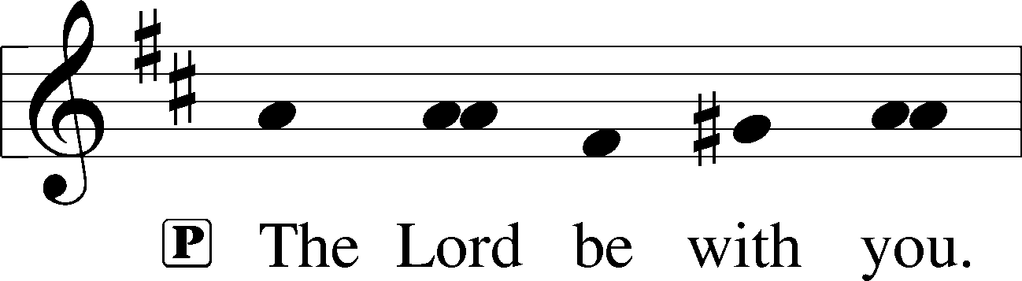

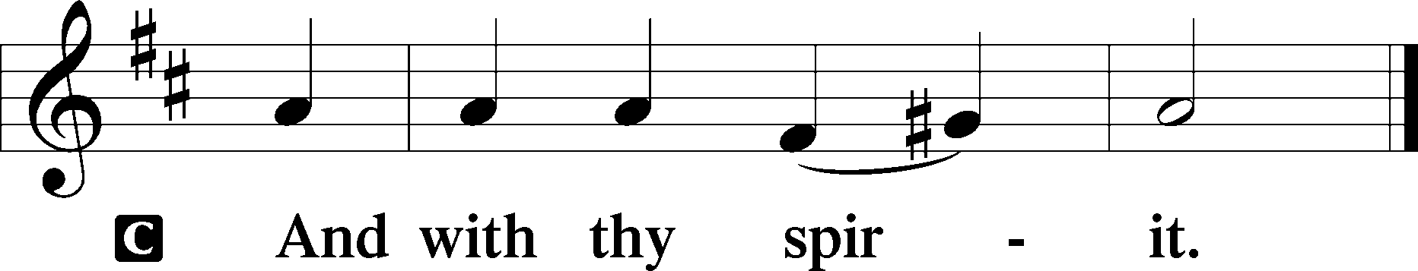

BENEDICAMUS LSB 202
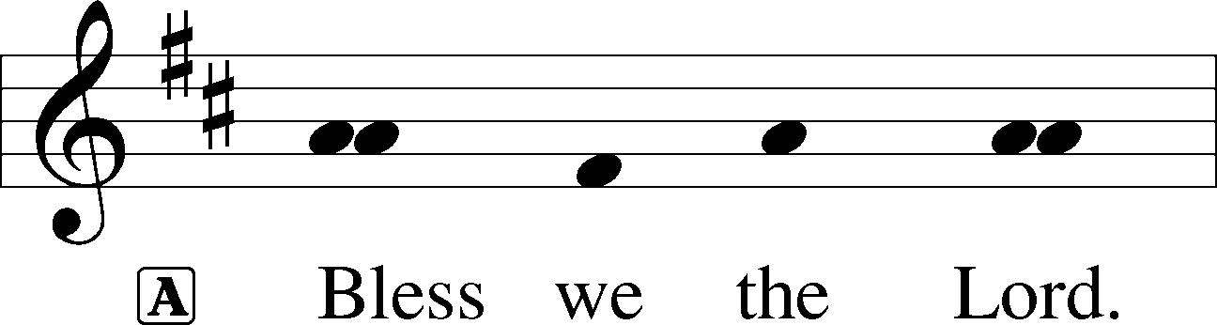

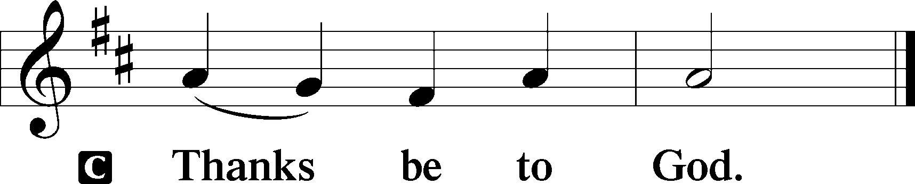

BENEDICTION LSB 202
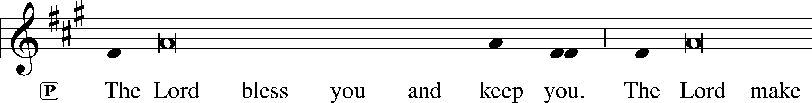
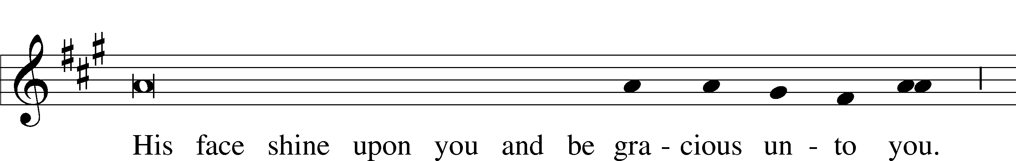
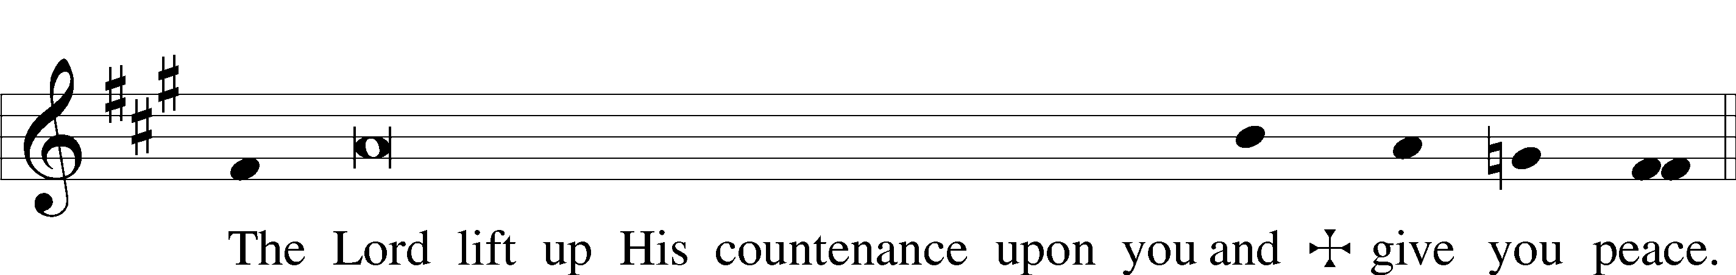

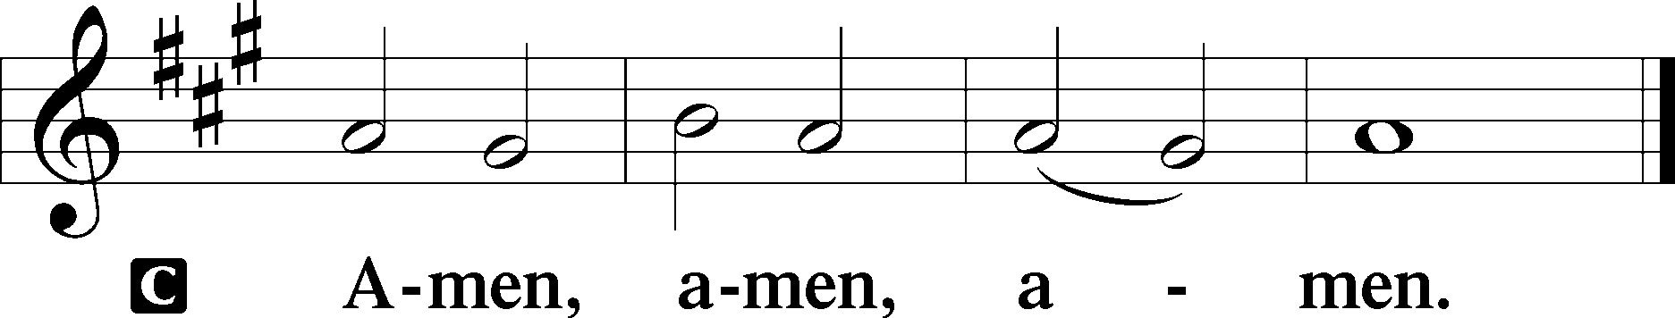

HYMN TO DEPART: 355 O SAVIOR, REND THE HEAVENS WIDE

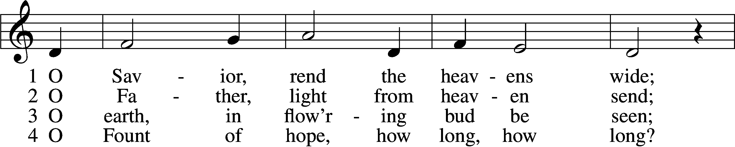
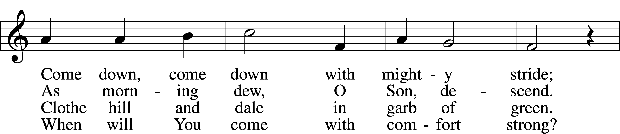
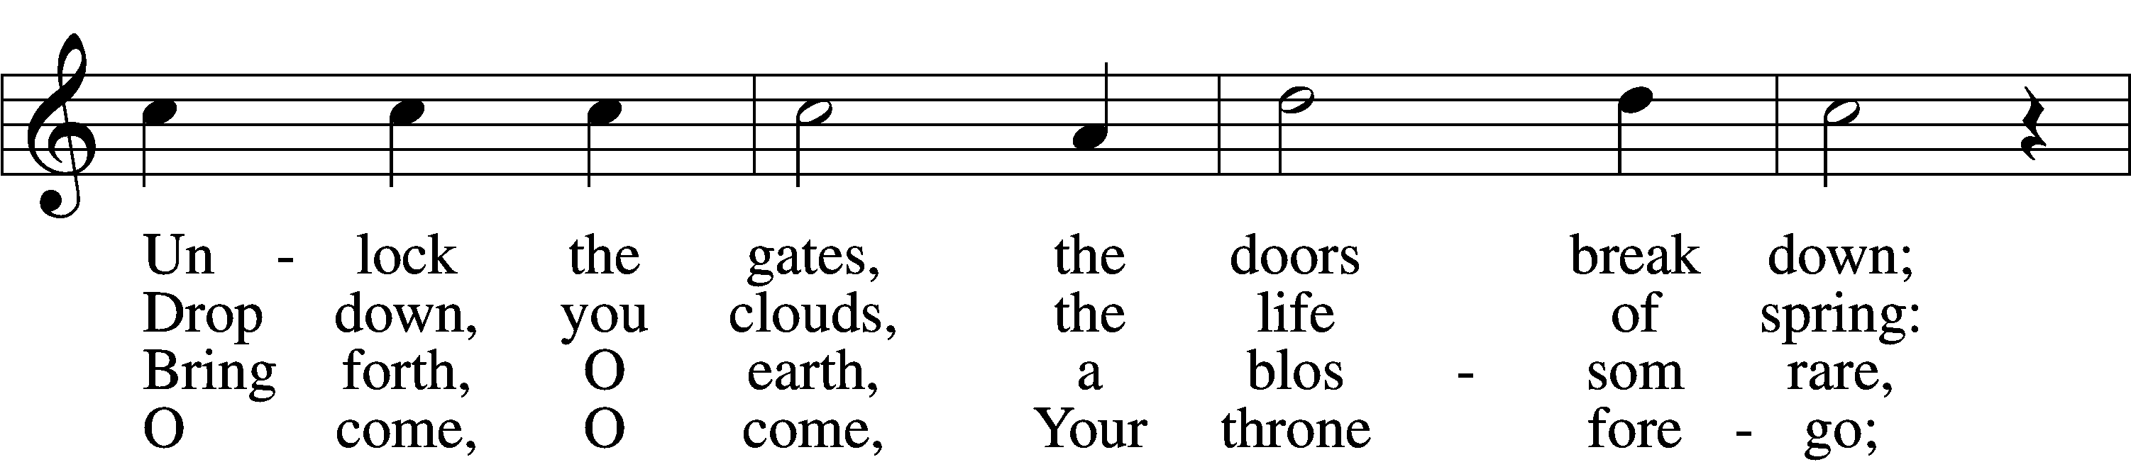
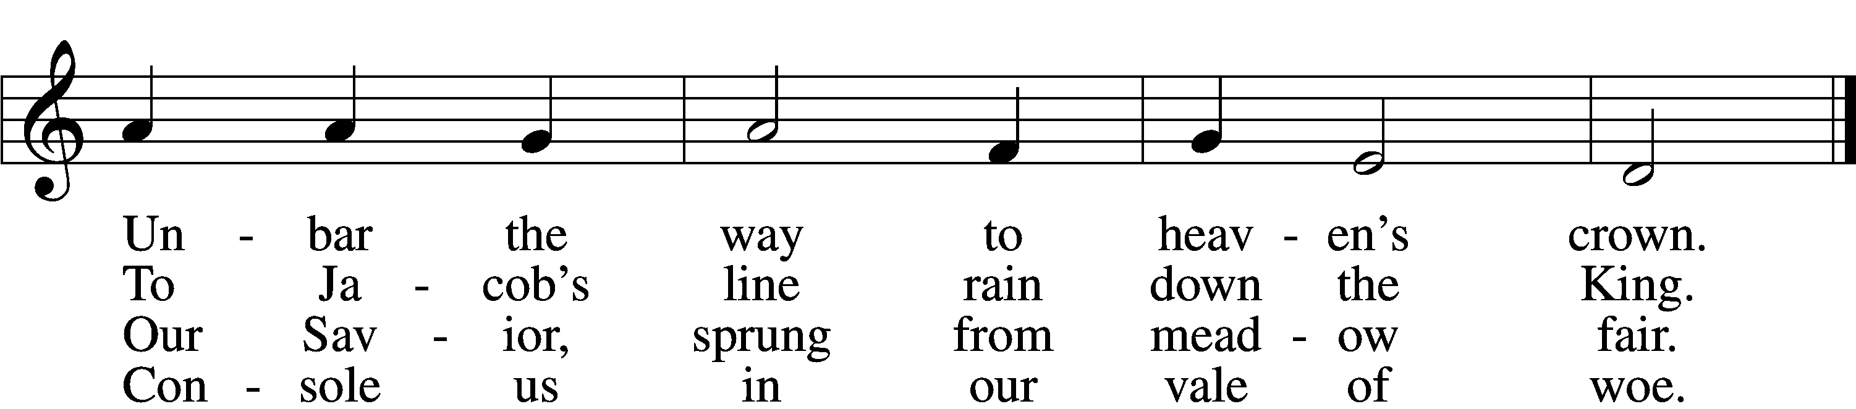

5 O Morning Star, O radiant Sun,
When will our hearts behold Your dawn?
O Sun, arise; without Your light
We grope in gloom and dark of night.

6 Sin’s dreadful doom upon us lies;
Grim death looms fierce before our eyes.
O come, lead us with mighty hand
From exile to our promised land.

7 There shall we all our praises bring
And sing to You, our Savior King;
There shall we laud You and adore
Forever and forevermore.
Tune: Public domain
Text: © 1969 Concordia Publishing House. Used by permission: LSB Hymn License no. 110003463

ACKNOWLEDGMENTS
Divine Service, Setting Three from Lutheran Service Book
Unless otherwise indicated, Scripture quotations are from the ESV® Bible (The Holy Bible, English Standard Version®), copyright © 2001 by Crossway, a publishing ministry of Good News Publishers. Used by permission. All rights reserved.
Created by Lutheran Service Builder © 2020 Concordia Publishing House.

Thank you to all who provided poinsettias

Dottye Wolf: In memory of loved ones.

Kelle Swyres: In memory of Robert & Karen Sandcork.

Emmett & Sharon Swyres: In honor of our great grandchild, Emmett.

Tim, Christy & Nikki Rush: In memory of Mary Goddard & Dan Rush.

David & Carla Roedemeier: In memory of Milton & Virginia Roedemeier and Carl & Mignon Webb.

Jim & Sue Perry: In honor of Tina Key’s 103rd birthday.

Helen Mumma: In memory of Richard Mumma.

Ben & Jean McWilliams: In memory of loved ones.

Christa McElroy: In memory of my mother.

Jean Kramme: In memory of my parents.

Helen Hoertel: In memory of Fred & Julia Hoertel, Martin & Flora Schake and Dorothy Meyer.

Martha & JD Cox: In memory of Paul & Frieda Munger and William & Juanita Cox.

Lee Clover: In memory of Anita Clover.

Gordon & Kathy Carlson

Wayne & Kay Beasley: In memory of Patrick.

Matt & Sue Banholzer: In memory of Anna Lee Young (Sue’s mom).

Andy & Nancy Anderson: In memory of Mom & Al.
ANNOUNCEMENTS

FRIENDLY REMINDER: Any charitable donations made to the church for 2020 tax purposes MUST be received by the church office or placed in the offering plates no later than Sunday, December 27th. Any donations/offerings made after that date will be applied to 2021.

The 2021 offering envelopes are available in the narthex. If you did not receive envelopes and would like one, please contact Robert Berkelman or the church office to request a set.

The following events have been CANCELLED: Sunday school, confirmation classes and Lutheran Student Fellowship.

Due to Rolla City Council ordinance that came into effect Friday, November 27th we are now limited to 25 parishioners per service in the sanctuary, 22 per service in the Fellowship Hall, for a total of 47 per service. We have added a second service on Sunday. There will be a Divine Service at our normal time of 9:00 am and a second Divine Service, without music, at 10:30 am. Both will have the Lord's Supper. We will also continue with our Mid-week Divine Service at noon on Wednesdays with the Lord's Supper.

Please reserve a seat for the service you prefer by using the sign-up sheets provided in the narthex, emailing the church at ilc@rollanet.org or calling the office Monday-Friday between 8:30 am and 2:00 pm. Please make your reservations by noon on Thursday for the Sunday service and noon on Monday for the Mid-week Divine Service.

**All parishioners are required to wear a mask in Church.**

Christmas Eve Services will be held Thursday, December 24th at 6:00 pm.

Christmas Day Services will be held Friday, December 25th at 9:00 am.

Please make your reservations as soon as possible.

Thursday Noon Bible Study will meet in the sanctuary.

Money counters needed! There are two open spots for money counters. If you are interested in volunteering please contact Robert Berkelman.

Thank you, Bob and Debbie Lemen, for providing altar care today.

